CHM 2000 Name________________________
Sinex
Discovering Beer’s Law by a Simulation-based Laboratory

This activity will require the exploration of Beer’s Law using a PhET simulation that is available at: https://phet.colorado.edu/sims/html/beers-law-lab/latest/beers-law-lab_en.html. Click on the Beer’s Law icon. A fully annotated screenshot is given below plus the variable wavelength and solution selection opened. This allows three variables to be explored: wavelength, pathlength, and molar concentration. This is an oversimplified spectrophotometer, which is used as an analysis in the laboratory.

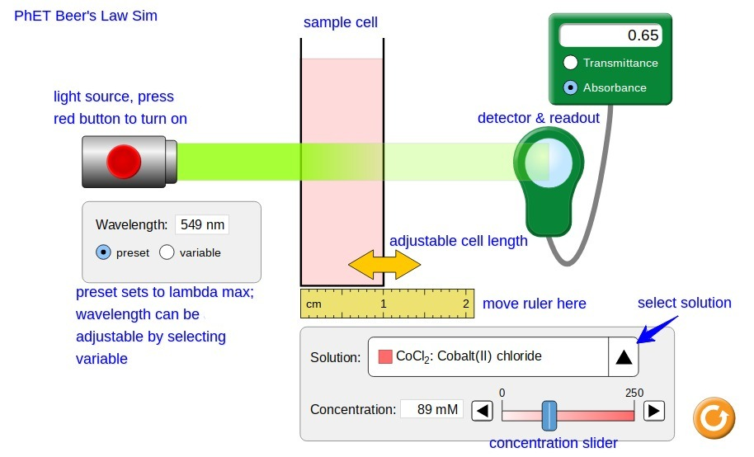
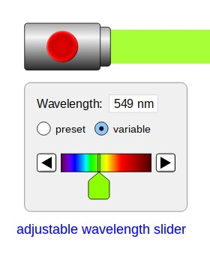

When the variable button is selected, the option to choose a wavelength in the visible spectrum of electromagnetic radiation is provided by the adjustable slider (paddle).

In spectrophotometry, the wavelength of maximum absorbance (preset) is used for analysis. This is found by determining an absorption spectrum. More about this later in the activity.

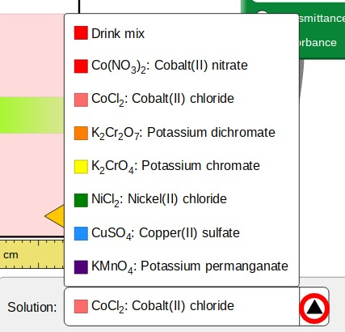
The arrow, circled in red below, allows the selection of a variety of solutions with different colors.

Notice the compounds all contain a group B element.

Flip through a number of the solutions and note the color of the solution and the color of the light. What happens to the beam of light on passing through the colored solution?

For more on the color of Group B elements, see Color and the Colors of Complexes.

A video showing the above sim features is at https://www.youtube.com/watch?v=C_ZLxsNnp2Q.

Investigating the Influence of Pathlength, b
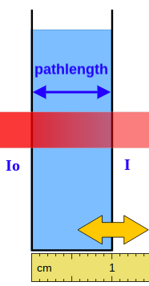
The pathlength, b, typically in centimeters, is the length that the light beam travels through the solution (width or diameter of sample cell). The pathlength can be adjusted by clicking on the double-headed golden arrow, holding the click, and dragging.

During the passage through the colored solution, the light is absorbed. The initial light intensity, I_{o}, decreases to I or I_{o} > I. The I/I_{o} is the fraction of light transmitted or transmission, T. The amount of light absorbed is 1 - T.

This is seen on the full screenshot on the first page as well for CoCl₂.

This decrease in light intensity allows for the absorbance, A, to be
defined as by the equation given below:

$A = -log T = -log \frac{I}{I_{o}}$

When doing spectrophotometry, ie - real measurements, to minimize error the absorbances are measured with the range of 0.1 to 1.0. Both A and T are unitless numbers, since the units of intensity cancel in the ratio.
This activity is going to examine the influence of pathlength, wavelength, and concentration on absorbance, A. Your instructor will share a Google Sheets spreadsheet to aid in the recording of data and analysis.

Open the PhET sim and set the items as shown on this screenshot.

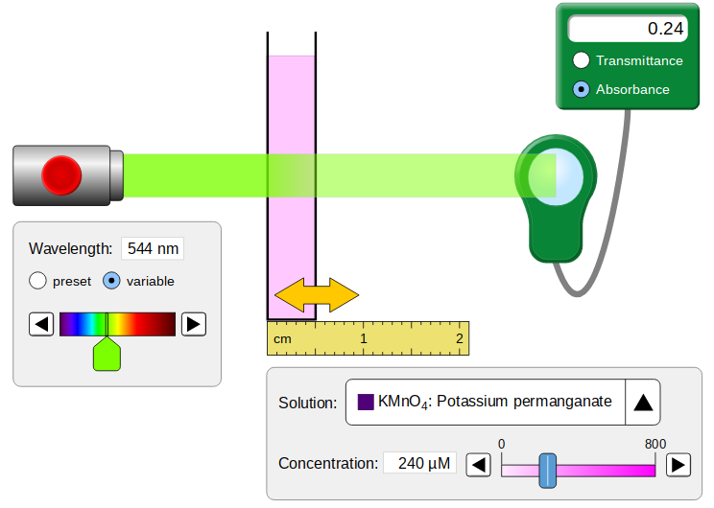

For a wavelength of 544 nm and a concentration of 240 micromolar (𝞵M), record the absorbance for a pathlength of 0.5, 1.0, 1.5, and 2.0 cm in the spreadsheet. Repeat for 180 micromolar.

What variables are constant (not changing)?

Investigating the Influence of Wavelength, 𝛌

For a pathlength of 1.0 cm and concentration at 480 micromolar (𝞵M), record the absorbance for the wavelengths, 𝛌, given on the spreadsheet. Repeat for a concentration of 240 micromolar. The wavelength of maximum absorbance is called the lambda max, 𝛌_{max}.

What variables are constant (not changing)?
The graph produced is an absorption spectrum, a plot of absorbance as a function of wavelength. Typically a scan of visible light from 400 to 650 nm.

Since the pathlength and molar concentration are held constant on the absorption spectrum, this is really a plot of how the molar absorptivity, a, which varies with the wavelength. The absorptivity is a measure of how strong a substance absorbs light at a specific wavelength. The larger the absorptivity or molar absorptivity, the greater the substance absorbs. For organic compounds, the greater the number of conjugated double bonds (alternating double-single bonds), the higher the value of the molar absorptivity will be. So molar absorptivity depends on wavelength, a(𝛌).

Investigating the Influence of Concentration, c

For a wavelength of 544 nm and a pathlength of 1.0 cm, record the absorbance for the concentrations, c, given on the spreadsheet. Repeat for a pathlength of 1.5 cm.

What variables are constant (not changing)?

This graph is a calibration curve, a plot of absorbance as a function of molar concentration. It is produced by analyzing a series of standard solutions (solutions of known concentrations).

Multivariable Analysis of the Graphical Data and Regression Results

Multi-variable equation: PV=nRT so for Charles Law or V-T plot: V = kT or V = (nR/P)T and why we hold n and P constant. So the slope of a Charles Law plot, m = nR/P, and if n or P changed how would the slope change? If n ⇑ slope ⇑ and if P ⇑ slope ⇓. Now apply this to your results.

Using the results provided on the spreadsheet, derive an equation considering the variables plotted (NO y or x in the equations). For constants in any equation, are they another one of the variables? Consider if they influence the behavior on the graph.

The calibration curve allows for the analysis of unknowns. The absorbance is measured and then the concentration found by interpolation on the graph or, better yet, calculated from the linear regression results. This is a powerful method of analysis in chemistry and many others areas as well. The use of absorbance, A, in place of transmittance or transmission as %T, linearizes the relationship as a direct proportion.

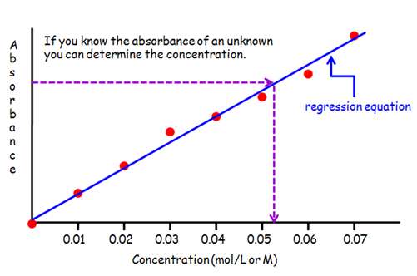

From the graphical analysis above, write a mathematical statement of Beer’s Law using the variables with their appropriate symbols given above.

Be sure that you can define all the symbols!

What are the units for all the variables?

Now go to the CHM 2000 webpage and examine the Beer’s Law Simulator and accompanying activity. This is an interactive Excel spreadsheet that allows you to adjust variables and see how the graph responds.

Post-lab Questions

To address the questions, get the data collected on a Spec-20D+ in this G Sheets spreadsheet:

Beer'sLawSimLab_PostLabQuestions_Data

All your answers should be placed on this spreadsheet and rename it with your name as shown and, when finished, share it with editing privileges with your instructor:

Your_Name_Beer'sLawSimLab_PostLabQuestions_Data

- Plot an absorption spectrum for cobalt (II) chloride. Find 𝛌_{max} and calculate the value of the molar absorptivity at 𝛌_{max}.

2. For the six groups of former CHM 2000 students, plot the calibration curves (all on one graph) and include linear regression equations and r-squared values on the graph.

- Record the slope, y-intercept, and r-squared values below the data in the spreadsheet.

- Calculate the concentration of unknown S and the value of the molar absorptivity from the regression results for each group.

- Comment about the accuracy and precision for each group.

3. Why don’t we use transmittance or transmission of light?

Version 1, March 2020

