Study Guide: Chemistry Semester 1

Scientific Method & Nature of science

Define:
Hypothesis-
Theory-
Law-
What’s the difference between the three?
Accuracy-
Precision-
What unit expresses volume?
List the SI Units for mass, length, volume, temperature, time, energy, density

What do these prefixes mean? Kilo, centi, milli
Convert 62hm to meters
Convert 800 mg to g
How many sig figs are in each number?
- 5043 b. 10.01 c. 3.50 d. 7.0200
Put these numbers into scientific notation:
- 6030000000 b. 0.000000047
Multiply the following numbers and report your answer to correct # of sig figs
12.5 x 3.241
Review the models of the atom and check them off as you go:
a. _____Thompson plum pudding, equal distribution of electrons in positive pudding
b. _____Rutherford electron cloud is mostly empty space, atom has a dense Positively charged center
c. _____Bohr shows electron cloud being made of orbits or energy levels, electron location can be calculated, electrons orbit the nucleus
d. _____Quantum electrons move randomly inside if orbitals 90% of the time, Electron location cannot be calculated
Matter

What is the formula for density? _____________
What is the density of water ? _____________
If equal amounts of water, ethylene glycol (density = 1.11 g/mL, and butane (density = 0.599 g/ml), were mixed in a jar, which would be on top? On bottom?

Be able to calculate density by using the water displacement method to determine volume.

List at least four types of evidence that a chemical change has taken place:
1.
2.
3.
4.

Know the difference between physical properties & chemical properties.

Know the difference between homogeneous vs. heterogeneous

Atomic & Molecular Structure
Atomic number
Atomic structure
- Draw an atomic model of
Carbon-13.
In the drawing include the following:
- Location of nucleus & electron cloud.
- Location of 3 subatomic particles.
- Amount of each subatomic particles.
- A note where most of the atom’s mass is found.

- What is atomic number?

- What is atomic number for the following elements?
Cr | Iron
Carbon | Ca

- How does atomic number change moving left to right across the periodic table?

Atomic Weight (Atomic Mass)
- What is the atomic mass for the following elements?
Organization of the Periodic Table
- Identify on the periodic table below the location of
The 3 different types of elements.
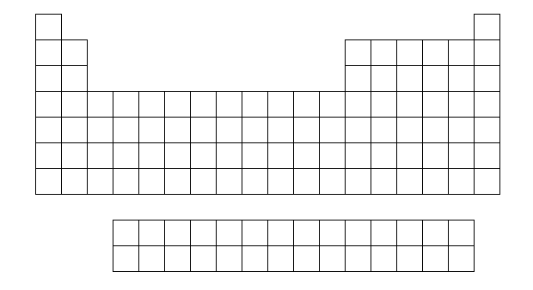
- Where are groups on the periodic table?

- Where are periods on the periodic table?
V | Oxygen
Beryllium | Mn

- It was found that the periodic table was organized by increasing atomic number rather than mass. Give an example of a pair of elements where one element has a larger atomic number but a smaller atomic mass.

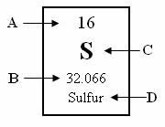
- Identify the letters in the following periodic square:

Atomic Structure (Continued)

Fill out the following chart:
Subatomic particle | Charge | Relative Mass | Location
proton
neutron
electron

A positive ion has more ___________ than ____________.
A negative ion has more ___________ than ____________.
A neutral atom has an ______ ____________ of ___________ and ___________.
An isotope has the same number of _____________ of other isotopes of that element, but it contains a different number of ____________.

Isotope | Atomic Mass | Mass Number | Protons | Neutrons | Electrons
U - 240
U - 238

Helium has two naturally occurring isotopes, helium-3 and helium-4. The atomic mass of helium is 4.003 amu. Which isotope is more abundant in nature?

Write electron configurations for Na, P, Li, F, Ar, Cu

How many principal energy levels are there and how many electrons can each hold?

How many sublevel types are there and how many electrons can each hold?

How does ground state differ from excited state?

If a wavelength of a band of light is known to be 3.45 x 10^-7m, wha tis the frequency of this band?

Periodicity (periodic trends)

Group Name | Group Number | Valence Electrons | Solid, liquid, gas?
Alkali metals
Halogens
Noble gases
Chalcogen
Alkaline earth metals

Know the electron configuration for each element of the periodic table.
Ex: F ____________________________ Ca ____________________________

Which elements are liquids?
Which elements are gases?
Which elements are metalloids?

Metals form ____________ ions
Nonmetals form ____________ions

Give 5 characteristics of a metal:

Give 5 characteristics of a nonmetal:

Describe how electromagnetic radiation is emitted: (know all the steps)

Know the following periodic trends:
Trend | Across the period | Down a group
Atomic radius -
Ionic radius -
Electronegativity -
Ionization energy -

What happens to the radius of an atom that becomes a positive ion?

What happens to the radius of an atom that becomes a negative ion?

Atomic Radius
  - Which element has the largest atomic radius?
  - Which element has the smallest atomic radius?

Ionization energy
  - What is Ionization Energy?
  - Which element has the largest ionization energy?
  - Which element has the lowest ionization energy?
  - Why does ionization energy decrease moving down a group?

Electronegativity
  - What is Electronegativity?
  - Which element has the largest electronegativity?
  - Which element has the lowest electronegativity?
  - Why do Noble Gases tend to have no electronegativity?
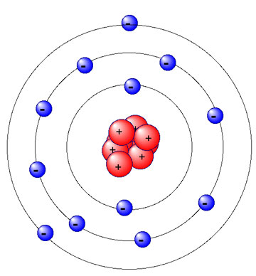

Valence electrons
- Why are alkali metals so reactive?

- Why are halogens so reactive?

- Identify the amount of valence electrons in each of the following:
- How many of magnesium atom’s 12 electrons are valence electrons? Circle those electrons.
Na | Phosphorus
Argon | He

Ionic Bonding and Nomenclature
- Positive ions are called ______________. Negative ions are called ______________.

- Why do chemical bonds form between atoms? (or…Why don’t atoms just stay single?)
________________________________________________________________________________________________________________________________________________________________
- In an ionic bond, electrons are shared / transferred / connected between atoms. (circle one)

- Ionic bonds form between ____________ and ____________. (metals, nonmetals, metalloids)
- For the pairs of elements listed below, circle pairs that would likely form ionic bonds.

C and H Na and F Hg and Ag Mg and S N and C K and O
- What is a polyatomic ion? ______________________________________________________________________________
- Circle the ionic compounds listed below.

CaSO₄ CH₄ CO₂ BaCl₂ NH₃ KNO₃ LiOH

- How did you know which compounds in Question 8 above were ionic?
________________________________________________________________________________________________________________________________________________________________
- What are binary ionic compounds? ________________________________________________________________________________
- Binary ionic compounds typically end with the suffix –_____.

- A “formula unit” is the simplest or lowest ____________ of ___________ in an ionic compound.

- How do each of the following atoms achieve a stable octet?
(circle gain or lose and write in a number of electrons)
O will gain / lose ___ electrons
Li will gain / lose ___ electrons
N will gain / lose ___ electrons
- List the oxidation number (charge) for the following groups of elements.
Group 1 ___ Group 15 ___
Group 2 ___ Group 16 ___
Group 3 ___ Group 17 ___

- List 3 physical properties of ionic compounds:

1. State: solid / liquid / gas (circle)
2. Melting Point: high / low (circle)
3. Conductor of electricity when _________________ or _______________
- Determine the total number of atoms in each formula listed below.

Li₃PO₄ ____ Ba(NO₃)₂ ____
- Determine the total number of ions in each formula listed below.

Li₃PO₄ ____ Ba(NO₃)₂ ____
- Which of the following compounds contains the Sn⁴⁺ ion?

a. Sn₂Br
b. SnCI
c. SnI₂
d. SnO₂

Write the NAME or FORMULA for the following molecular compounds:

13. CS₂ ______________________________

14. CCI₄ ______________________________

15. S₂O₆ ______________________________

16. triboron monoxide _______

17. tetraphosphorus pentoxide _______

18. arsenic trihydride _______

Describe the following bond types in terms of what happens to the electrons:
Ionic Bonds –
Covalent Bonds –
Metallic Bonds -
Bonding occurs to satisfy the __________ rule. Why?

Write the formula for the following compounds:
Magnesium hydroxide _________________
Aluminum nitride ____________________
Aluminum nitrate ____________________
Aluminum nitrite ____________________
Gold III phosphate ____________________
Gold III phosphide ____________________
Gold III phosphite ____________________

Write the formula for the following compounds:
Chloric acid ____________________
Sulfuric acid ____________________
Hydrosulfuric acid __________________
Dinitrogen pentoxide __________________

Name the following:
H₂CO₃ ____________________
SCl₆ ____________________
CuNO₃ ____________________
Ca₃(PO₄)₂ ____________________

The Mole and Mole Conversions

3. The SI unit used to measure an amount is a(n) ____________________.

4. What is molar mass? ___________________________________________________________________

5. Calculate the molar mass of:
a) CuSO₄ ________________ b) octane ________________

6. a) ____________________ = 1 mole = ____________________
b) 6.02 x 10²³ is called __________________________________.

7. How many moles are in 315 grams of magnesium chloride? ___________

8. How many grams are in 7.6 moles of dinitrogen trioxide? ___________

9. How many atoms are in 8.40 moles of aluminum (Al)? ___________

10. How many molecules are in 88.0 grams of carbon dioxide? ___________

11. How many moles are in 7.05 x 10²⁴ atoms of carbon (C)? ___________
12. How many grams are in 6.02 x 10²³ formula units of LiCl? ___________

The periodic table contains information for every element.
Define the terms atomic number, atomic weight, and mass number. Identify the atomic number, atomic weight, and mass number for carbon based on the information on your periodic table.

Atomic structure for any element can be determined from the information on the periodic table.
Describe the three subatomic particles, their charges, sizes, and locations in an atom.
Determine the number of protons, neutrons, and electrons for a Boron atom.

Bohr Models represent the structure of the atom with protons and neutrons in the nucleus and electrons on “rings” outside of the nucleus. Remember the first ring holds 2, the second ring holds 8, and the third ring holds 18.
Draw the bohr models for Na and Cl and Ar

Isotopes are atoms of the same element because they have the same number of protons but a different number of neutrons.
Determine the number of protons, neutrons and electrons in Hydrogen-1, hydrogen-2, and hydrogen-3

The last digit of an element’s group number is equal to its number of valence electrons.
Which contains the greatest number of valence electrons?
Ca Ge Se Kr

Draw one dot for each valence electron when drawing an element’s or ion’s Lewis electron dot diagram.
Which dot model would contain the fewest dots as valence electrons?
Ca Ge Se Kr

There are various trends that can be found on the periodic table. Define atomic radius, electronegativity, ionization energy, and electron affinity. Identify their trends using arrows and the words “increasing” or “decreasing” on the periodic table below.

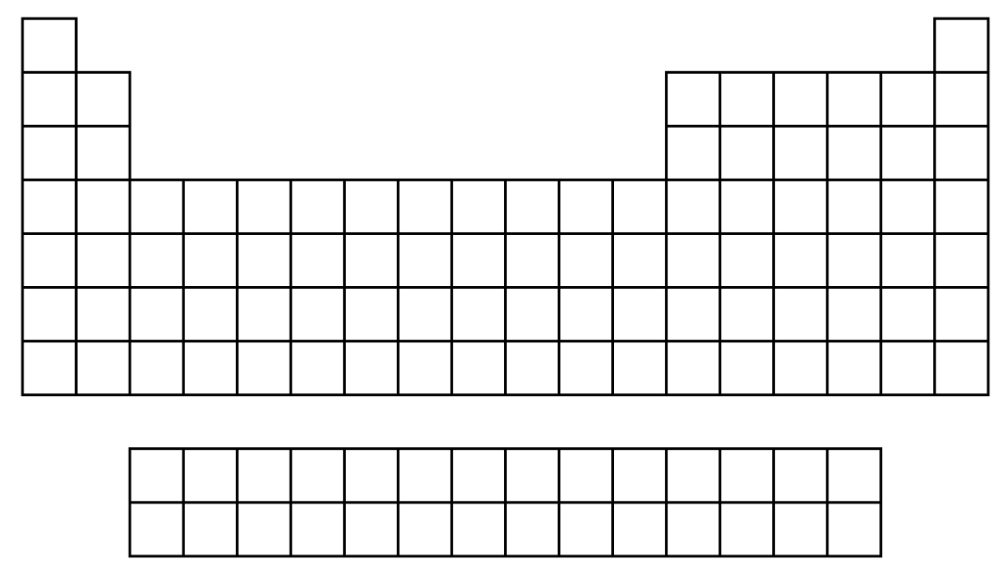

The three classes of elements on the periodic table are metals, nonmetals, and metalloids. Describe their general characteristics. Color all of the metals green, the metalloids red, and the nonmetals blue on the table above.
Atoms are most stable when they have 8 valence electrons (an octet) and tend to form ions to obtain such a
configuration of electrons.
Predict the charge of the ions formed by these elements
Li F Na Cl

Chemical formulas are written so that the charges of cations and anions neutralize (cancel) one another.
calcium phosphate: Ca2+ PO43- = ………… (criss-cross)

When naming binary ionic compounds, write the name of the positive ion (cation) first,
followed by the name of the negative ion (anion) with the name ending in “-ide.”
CaCl₂ …………….. MgS ……………..

When naming compounds containing polyatomic ions, keep the name of the
polyatomic ion the same as it is written on your reference sheet.
NH4Cl ………. copper (I) nitrate ……….

Roman numerals are used to show the positive oxidation number of the cation if it has more than
one positive oxidation number
FeO: ……………………. Nickel (III) sulfate: ……………..

Ionic bonds form when one atom transfers an electron to another atom when
forming a bond with it.
Which substance exhibits ionic bonding rather than covalent bonding?

CO₂ N₂O₄ SiO₂ CaBr₂ C₆H₁₂O₆

Substances containing mostly covalent bonds are called molecular substances.
They are attracted to each other by sharing electrons
Which of the following is a molecular substance?
Lithium chloride carbon monoxide sodium nitrate aluminum oxide

When naming a binary molecular compound, the first element is named using the name of the element.
The second element always end in “–ide.” Indicate the number of atoms using the prefix…
1 mono 2 di 3 tri 4 tetra 5 penta 6 hexa 7 hepta 8 octa 9 nona 10 deca
If the first element has only one atom, don’t use the mono.
What is the name of the following molecular compounds?
CO₂ ___________________________ N₂O___________________________

Complete and memorize this table
Substance Type | Properties
Ionic
Covalent (Molecular)

Physical changes do not form new substances.
They merely change the appearance of the original material. (The melting of ice) H₂O (s) H₂O (l)

Chemical changes result in the formation of new substances or the product(s) of a chemical reaction.
Which process is an example of a chemical change?
the melting of ice the electrolysis of water the boiling of water

The gram formula mass (molar mass) of a substance is the sum of the atomic masses of all the atoms in it. H2SO4 = ______ g/mole
2 x H = 2 x ………g = ………g
1 x S = 1 x ………g = ………g
4 x O = 4 x………g = ………g

Use the mole map to help you solve conversions
What is the mass in grams of 3.6x10²¹ molecules of sugar? C₁₂H₂₂O₁₁
What is the mass in grams of NaCl that was dissolved in 3.2 L to create a 1.6M solution?

Covalently bonded substances form molecules. Molecular compounds are made up of nonmetals only.
Which of the following are molecular compounds? H₂O CH₄ NaCl CuSO₄ CO₂

The formula of a molecular compound represents one molecule of the substance, also one mole of
molecules and the number of atoms for each nonmetal element making up the molecule.
The formula for methane gas, CH₄, tells us the make-up of one molecule of methane is 1 carbon atom and 4 hydrogen atoms covalently bonded together. We can also figure out the molar mass or the mass in one mole of methane. What is the molar mass of CH₄? 47 g/mol 24 g/mol 16 g/mol 10 g/mol

