Cellular Organization (pg 22-26)
Prokaryotes

Domains and Kingdoms that are included:
Eukaryotes

Domains and Kingdoms that are included:
Cells Must Have Boundaries
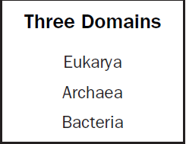
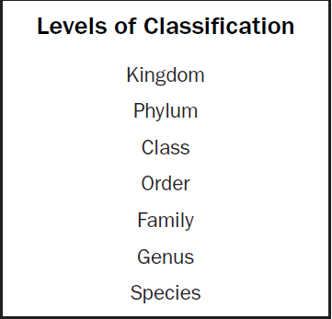
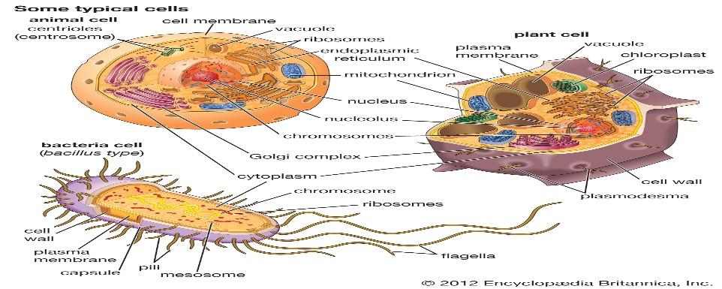
What are the Six Kingdoms of Life:

What is a virus and compare it to living organisms?

Organelle | Function | Bacterial | Plant | Animal
Nucleus
Cell Membrane
Rough ER
Smooth ER
Mitochondria
Chloroplast
Ribosomes
Golgi Body
Cell Wall

The importance of Homeostasis (pg 59-62)
Define tropism and describe how plants use different tropisms to survive stressful environmental conditions:
Tropism:
Gravitropism:
Phototropism:
Thigmotropism:
Photoperiodism:

Define the following types of transport and determine whether they are examples of Active or Passive Transport:
Passive Transport:
Active Transport:
Diffusion:
Osmosis:
Facilitated Transport:
Endocytosis:
Exocytosis:

Species Evolve over Time by Natural Selection (pg 63-68)
How does Natural Selection relate to changes in organisms, make sure to define the word “Fitness” and discuss its importance (pg 65)

Who is Charles Darwin and how did he come up with the theory of Natural Selection (pg 63):

Describe the following types of inheritance patterns and list examples of each (will need to look it up):
Incomplete Dominance:
Codominance:
Sex-Linked Traits:

What is a mutation, what are factors that can cause them and define the types of mutations that occur (pg 47):
Mutations:

Types of Mutagens:

Base-pair substitution:

Base insertion:

Base deletion:

Define Renewable and Non-Renewable resources and list examples of each (pg 66-68):

How do human activities influence and modify the environment? Include examples and discuss strategies that help address the issue. What happens to those materials that are not recycled or cannot be recycled or reused?

Define the two types of Environmental factors (pg 65):

List the examples of Biotic and Abiotic Factors:
Biotic:

Abiotic:
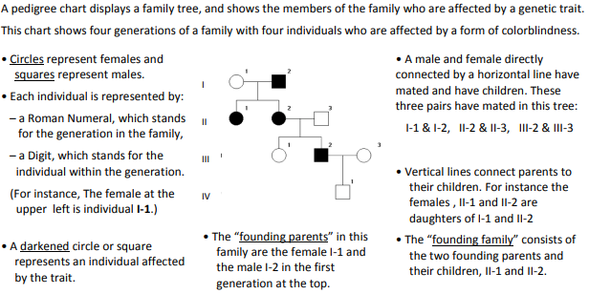
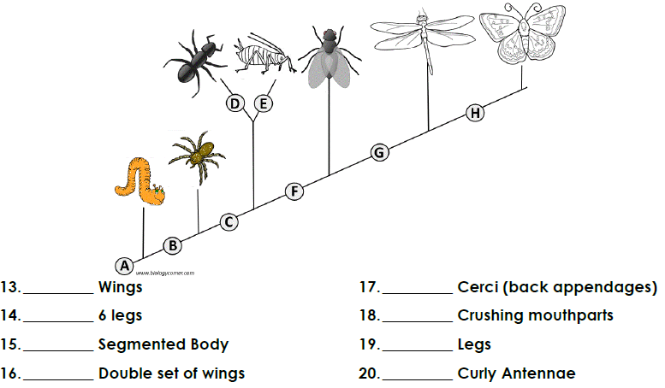
Complete the Protein Synthesis on this sequence of DNA (you will need to find an amino acid chart online):
DNA Sequence: ATG CAT TGA CAT TAA ATA GTA GTT ATT TAT GAT TCA

DNA Replication:
(DNA to DNA)

Transcription:
(DNA to mRNA)

Translation:
(mRNA to tRNA)

Amino Acid Synthesis:
(tRNA to amino acid)
Look up chart online

