Cellular Organization (pg 22-26)
Prokaryotes = No nucleus organism
-Lacks a nucleus
-Single Celled
-Organelles that don’t have membranes
Domains and Kingdoms that are included:
Eubacteria: modern bacteria, makes you sick, ex. Salmonella & E. Coli
Archaebacteria: oldest living organisms, found in extreme environments like hot springs
Eukaryotes= True/has nucleus organism
-Have a nucleus w/DNA
-Single and multicellular
-Have membrane bound organelles/structures

Domains and Kingdoms that are included:

Plants: Photosynthesizers: Make food from sunlight. Ex: grass
Animals: Most developed group of organisms. Ex: Human beings
Fungi: Decomposers, break down organic matter for energy. Ex: Mushrooms
Protists: The most diverse group of organisms on the planet Ex. Ameobas
Cells Must Have Boundaries
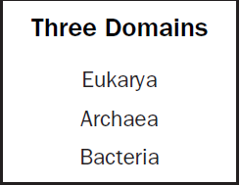
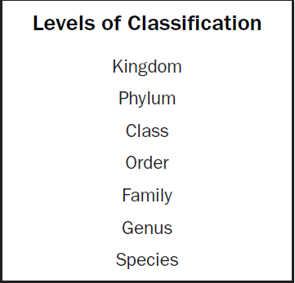
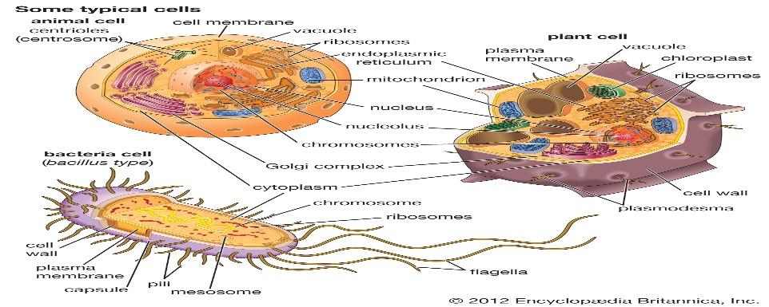
Dear King Phillip Came Over For Great Spaghetti
Domains Kingdoms Phylum Class Order Family Genus Species
What are the Six Kingdoms of Life:
Archaebacteria, Eubacteria, Protists, Fungi, Plants and Animals
What is a virus and compare it to living organisms?
Infectious particles that are made up of protein shells called a capsid and contain either DNA or RNA. IT IS NOT LIVING AND CANNOT REPRODUCE.

Organelle | Function | Bacterial | Plant | Animal
Nucleus | Contains DNA and controls cellular functions |  | √ | √
Cell Membrane | Controls what goes in and out; Maintains homeostasis (internal balance) | √ | √ | √
Rough ER | Making Proteins and it is made up of the Ribosomes |  | √ | √
Smooth ER | Making Lipids/Fats |  | √ | √
Mitochondria | Makes ATP; Powerhouse of the Cell ; Cell Respiration |  | √ | √
Chloroplast | Makes Glucose by capturing the solar energy for photosynthesis |  | √
Ribosomes | Make Proteins (Workers of the cell) | √ | √ | √
Golgi Body | Modifies, sorts, and ships proteins and lipids |  | √ | √
Cell Wall | Protects the Cell from the outside | √ | √

The importance of Homeostasis (pg 59-62) = to maintain an internal balance (Controlled by the Cell Membrane)
Define tropism and describe how plants use different tropisms to survive stressful environmental conditions:
Tropism: When plants respond to their environments. “To Turn towards”
Gravitropism: Response of the seedlings to the force of gravity; Roots go down and stems go up
Phototropism: Plants respond to light; They turn towards the sun/light
Thigmotropism: Plants responding to touch; Climbing plants, ivy and vines use solid objects for support and grow around it.
Photoperiodism: Plants responding to the stimuli from the environment; Depending on the length of light and seasons plants bloom/adapt

Define the following types of transport and determine whether they are examples of Active or Passive Transport:
Passive Transport: It requires no energy, move particles from an area of high concentration to an area of low concentration. With the concentration gradient.
Active Transport: Uses Energy or ATP. Moving particles from an area of low concentration to an area of high concentration. Against the concentration gradient.
Diffusion: Used for the movement of gases; Used to bring oxygen into the body and take out carbon dioxide. Use no energy and go from High to Low. Ex: Spraying Cologne in your room [PASSIVE TRANSPORT]
Osmosis: Used for the movement of water; Used to bring water into and out of the cell. Uses no energy and goes from High to Low (Water follows SALT/SUGAR) [PASSIVE TRANSPORT]
Facilitated Transport: Movement of small food particles with the help of a protein; Used to bring small particles of food inside and out of the cell through a protein channel. [PASSIVE TRANSPORT]
Endocytosis: Bringing Large Molecules into the cell by using energy. [ACTIVE TRANSPORT] The cell surrounds the particle and takes in the material into the cell.
Exocytosis: Take out Large Molecules out of the cell by using energy. [ACTIVE TRANSPORT] The cell surrounds the particle and removes the materials out of the cell.

Species Evolve over Time by Natural Selection (pg 63-68)
How does Natural Selection relate to changes in organisms, make sure to define the word “Fitness” and discuss its importance (pg 65)
Fitness: relative reproductive efficiency (how healthy are you to reproduce)
-The fitness of an individual depends on the probability that the individual will first survive and secondly reproduce successfully.
-It is NOT NECESSARILY the strongest, biggest, or most aggressive animal that has the highest fitness rating.
It depends on the organism’s structure, physiology (shape), biochemistry (what the person is made up of) and behavior which give the organism the BEST chance to survive and reproduce.
Who is Charles Darwin and how did he come up with the theory of Natural Selection (pg 63):
Darwin was an observer in the 1800’s who was observing the variations within plant and animal species. He came up with the theory of Natural Selection.

Natural Selection: Only the healthiest organisms will survive and are the most likely to reproduce, they will only pass the healthiest of traits down to their offspring “Survival of the fittest”
Describe the following types of inheritance patterns and list examples of each (will need to look it up):
Incomplete Dominance: When neither trait wins and a blending event happens; White flowers mixed with Red flowers make all PINK flowers
Codominance: Both traits show up together in an organism; Spotting occurs; White hair mixed with brown hair makes white and brown spots/patches.
Sex-Linked Traits: Located on the sex chromosome. The 23rd chromosome. Usually come from the X chromosome; usually comes from mom and affects males because they have the recessive gene.

What is a mutation, what are factors that can cause them and define the types of mutations that occur (pg 47):
Mutations: Anytime there is change in the DNA sequence
Caused by Mutagens: An agent that causes a mutation
Types of Mutagens: UV light, ionizing radiation, free radicals, tobacco products and other chemical compounds.
Base-pair substitution: One nucleotide base is replaced with another
Normal: ATG GAT
Mutated: AAG GAT
Base insertion: an addition of a nucleotide base into the sequence.
Normal: ATG GAT
Mutated: ATG GAT C
Base deletion: a removal of a nucleotide base from the sequence
Normal: ATG GAT
Mutated: ATG GAT

Define Renewable and Non-Renewable resources and list examples of each (pg 66-68):
Renewable: Sources of energy that can be replaced or replenished by natural processes within a human life span. Ex: Soil, plants, water, crops, animals
Non-Renewable: Sources of energy that are only available in limited amounts. Once they are gone, they are gone! Ex: tin, silver, gold, uranium, copper, Phosphorous, Topsoil, and fossil fuels (very slow)
How do human activities influence and modify the environment? Include examples and discuss strategies that help address the issue. What happens to those materials that are not recycled or cannot be recycled or reused?
Pollution: Anytime you contaminate the soil, air, water as a result of human activity.
Air Pollution: Burning of Fossil Fuels, Polluting the air with dust, smoke, ash, carbon monoxide, sulfur oxides (Acid Rain)
Water Pollution: contaminate the sewers, industries, farms, and homes by introducing sewage, chemical wastes, fertilizer, and dirty wash water.
Ways in which Humans are controlling their impact on the environment:
“three R’s”: Reduce, Reuse, Recycle.
Wildlife conservation: protects species from losses of habitats, overhunting, and over population/pollution.
Limit the use of energy resources: Reduce the use of Fossil Fuels, increasing public transportation/carpooling. Energy efficient houses.
Define the two types of Environmental factors (pg 65):
Biotic- Living things
Abiotic- Non-Living things
Organization of life in Ecology:
Organisms (1 Human being)-Species ( Human beings)-Population (Human Beings)-Communities ( Human beings and other animals)-Ecosystems( All living and non-living things-Biomes-Biosphere
List the examples of Biotic and Abiotic Factors:
Biotic: Plants, Animals, Bacteria
Abiotic: Climate, Light, Soil, Water
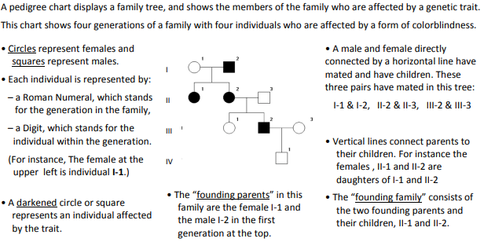
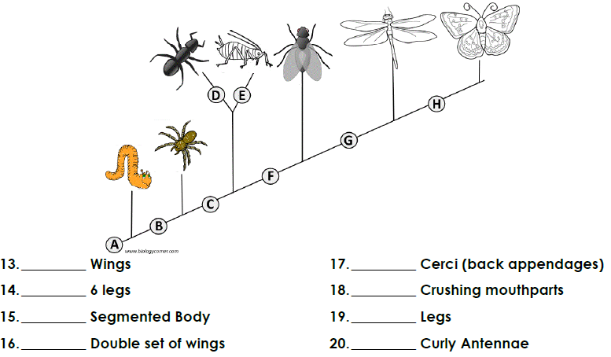
H
B
D
E
C
G
A
F
Complete the Protein Synthesis on this sequence of DNA (you will need to find an amino acid chart online): DNA: [(A-T), (G-C)]; RNA: [(A-U), (G-C)]
DNA Sequence: ATG CAT TGA CAT TAA ATA GTA GTT ATT TAT GAT TCA

DNA Replication: TAC GTA ACT GTA ATT TAT CAT CAA TAA ATA CTA AGT
(DNA to DNA)
Copy DNA in the Nucleus
Transcription: AUG CAU UGA CAU UAA AUA GAU GUU AUU UAU GAU UCA
(DNA to mRNA)
Nucleus to Ribosomes/Cytoplasm
Translation: UAC GUA ACU GUA AUU UAU CUA CAA UAA AUA CUA AGU
(mRNA to tRNA)
Ribosomes
Amino Acid Synthesis: TYR VAL THR VAL ILE TYR LEU GLN STOP ILE LEU SER
(tRNA to amino acid)
Look up chart online

