Life is a Gas! (Extra Credit)

Name_________________

In this activity we will address the question: What are the laws and calculations governing gas behavior?

Model 1: Gas Simulation from University of Colorado- PhET.
The program is a model of a gas at the molecular level. It measures and controls several variables. àRobert Boyle was a British physicist who discovered the relationship between as gas’s pressure and its volume: Boyle’s Law.
àJacques Charles was a French scientist who discovered the relationship between a gas’s temperature and its volume: Charles’ Law.

- Start the PhET simulation on gases. Explore the simulation. Take 2 minutes and just play with it to see what it can do. If you have never used PhET before, you will need to set up a free account. https://phet.colorado.edu/en/simulation/gases-intro

- Locate the reset button on the simulation and push it to return the screen to the original state. What does the pressure dial read?

- With the heavy molecule species selected, pump the handle once and watch the pressure dial. What do you think pressure is and what causes it at the molecular level. Write a grammatically correct statement that describes pressure.

- Use the Internet to find a definition of pressure and its units of measure. Record your findings below. In what units is pressure measured in the simulation? How does this compare with what you found on the Internet? If the units are different, what is the conversion factor for the units you found?

- Pump the handle again. What happens to the pressure? Does this match with your idea of what pressure is and what causes it?

- Reset the simulation.

Temperature and Molecules

- Click the bar that says “Measurement Tools.” Click the check box that says “Species Information.” With the simulation set for the heavy (blue) molecule species, pump the handle once. What is the temperature in the system?

What is the average speed of the molecules?

- Add heat to the system until the temperature reads about 800 K. Now what is the average molecular speed?

- How are temperature and molecular speed related?

- Select the light (pink) molecular species on the pump. Without resetting the simulation, pump the handle once. Did the temperature change?

- How does the speed of the light molecules compare to that of the heavy species? Why do you think there is a difference?

Boyle’s Law: Discovering how gas volume and pressure are related.
Model 1: Reset the simulation and set it up as follows:
  - Click the heavy species (blue) molecules button on the pump. Pump the handle once.
  - Click the “Temperature” button in the “Constant Parameter” control panel.
  - Be sure ‘Gravity’ is set to 0.
  - Click the “Ruler” button in the “Tools” menu.
  - Position the ruler on the bottom of the chamber so that the “0 nm” mark is aligned with the left end of the chamber. Your screen should look like this:
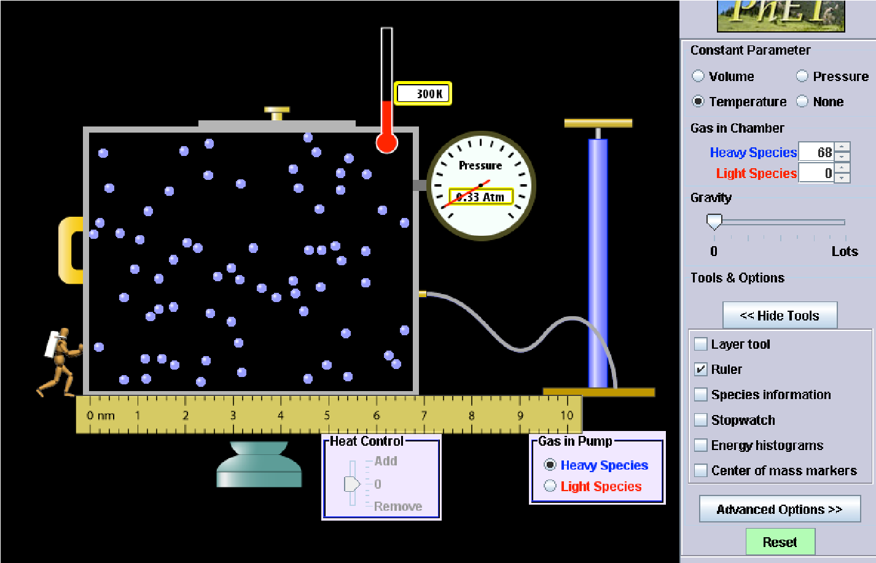

- Manipulate the system by moving the left handle of the chamber to reduce the volume. Move the handle to the right. Reposition the ruler so the 0 mark is at the left side of the chamber. Assume that the chamber is 5 nm high and 20 nm deep. Record the length of the chamber below. How will you calculate the volume of the chamber? Calculate the volume of the chamber and record it below. Record the pressure as well. Is there a limit to how far you can push the handle in?

Record your results in the following table. Record pressures for at least 7 different measurements on the ruler besides 0 nm.
Chamber  Length (nm) | Volume (nm³) | Pressure (atm)

- Sketch a graph of the results of your experiment with volume on the horizontal axis and pressure on the vertical axis. What is the relationship between pressure and volume? (hint: you can answer this in several ways like “as P increases, V ______”, direct or inverse relationship, etc.)

- In the experiment, what happened to molecular speed when the pressure and volume changed? Make a guess (hypothesis). Go back to the simulation and click the species information box. Change the volume and note what happens to the molecular speed. Were you right? Note the correct response here.

Charles’ Law: Discovering how gas volume and temperature are related.
Model 2: Reset the simulation and set it up as follows:
  - Click the heavy species (blue) molecules button on the pump.
  - Pump the handle twice and allow the pressure to stabilize.
  - You may also want to increase the temperature to about 500 K.
  - Click the “Pressure” button in the “Constant Parameter” control panel.
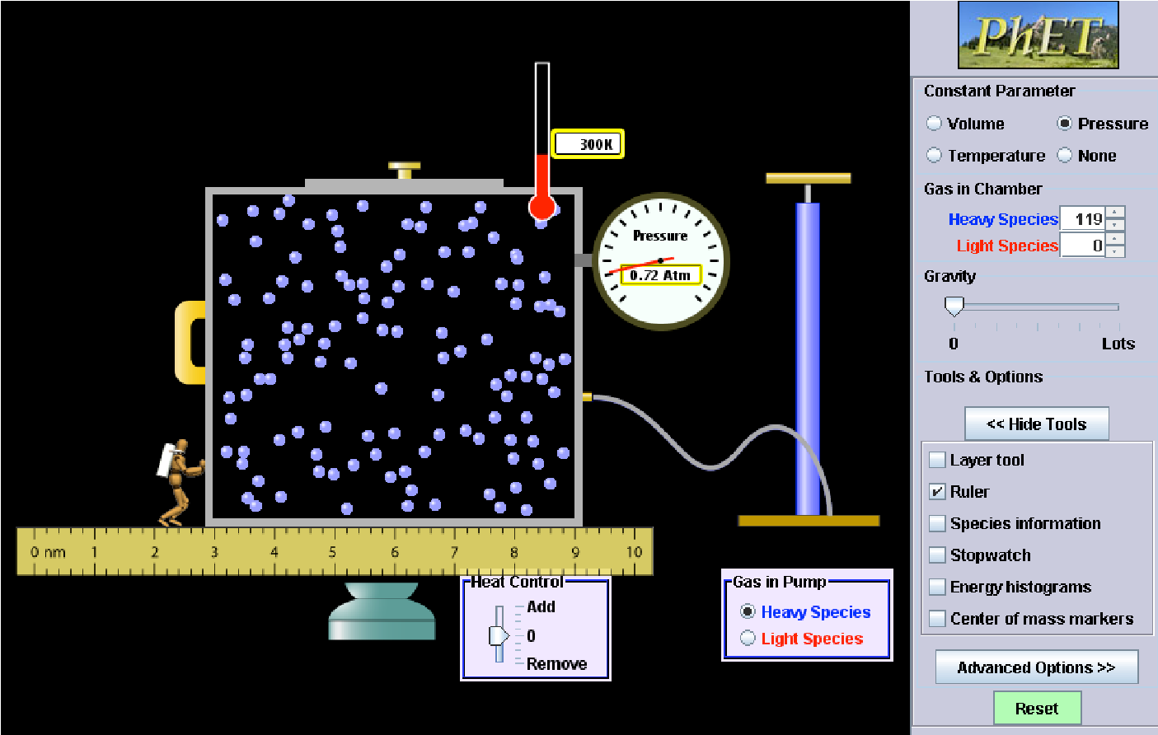
  - Set Gravity to 0. and 20 nm deep. Calculate the volume of the chamber.
•

Click the “Ruler” button in the “Tools” menu
.

•

Your screen should look like this:

•

Place the ruler so that the 0 mark is at the left end of the chamber.
Assume that the chamber is 5 nm high
  - Record the temperature and volume of the chamber below.

What is the stable pressure? ________atm

- Manipulate the system by removing heat. In each case, record the temperature and reposition the ruler with the “0” mark on the left end of the chamber and measure the size of the chamber. Record these values for 8 different temperatures. Make sure the pressure is not changing.
Temperature (K) | Chamber Length (nm) | Volume (nm³)
- Sketch a graph of the results. Be sure to put the lowest temperature first, then enter increasing temperatures with the highest temperature last. What is the relationship between temperature and volume of a gas?

Extending your knowledge.

BOYLE’s LAW

Robert Boyle’s conclusion was: V α 1/P. The Greek letter alpha (α) is a proportionality symbol. While proportionalities are useful for understanding a concept, they are somewhat useless mathematically. In order to eliminate the proportionality symbol, a constant is added to the expression, allowing us to use an “=” instead.
Boyle’s Law is then written V = k(1/P) which leads to V = k/P

- Solve the equation above for ‘k’.

- If a gas has an original volume of 8.0 L and a pressure of 0.81 atm (at constant temperature), what is the value of the constant ‘k’?

- What will be the new volume of the gas if the pressure changes to 1.4 atm?

- Is ‘k’ constant for your pressure/volume data from Model 1? Calculate the ‘k’ value for 3 data points. Is it close to the same in each case?
a)

b)

c)

- Do your result agree with what you discovered about how gas volume is affected by pressure?

- Summarize Boyle’s Law in your own words.

CHARLES’ LAW
Jacques Charles concluded that V α T at constant pressure. Again, we can eliminate the proportionality symbol: V = kT.

Special note: For any mathematical work involving gases, temperatures
MUST BE IN KELVINS! (Remember, K = ºC + 273.)

- Solve the equation V = kT for the constant ‘k’.

- What is the value of ‘k’ if the volume of a gas is 17.0 L at 500. K?

- What will be the new volume of the gas if the temperature drops to 200. K?

- Is ‘k’ constant for your pressure/volume data from Model 2? Calculate the ‘k’ value for 3 data points. Is it close to the same in each case?
a)

b)

c)

- Does your result agree with what you discovered about how gas volume is affected by temperature?

- As a group, summarize Charles’ Law in your own words.

THE COMBINED GAS LAW
Above you solved Boyle’s Law for ‘k’: k = VP. You also solved Charles’ Law for ‘k’: k = V/T.

Assuming that ‘1’ represents the original gas conditions and ‘2’ represents a new set of conditions… Boyle’s Law is sometimes written like this: V₁P₁ = k = V₂P₂, or simply V₁P₁ =V₂P₂

And Charles’ Law is written: V₁ = k = V₂ or V₁ = V₂
T₁ T₂ T₁ T₂

Because volume is a common factor in both equations, the 2 laws can be joined into one equation called the Combined Gas Equation.

P₁V₁ = P₂V₂
T₁ T₂

- Solve the following problems using the combined gas equation.
  - V₁ = 6.8 L, P₁ = 275 kPa, T₁ = 345 K. If V₂ = 5.4 L and P₂ = 630 kPa, what is the final temperature of the gas?

  - A weather balloon is filled with 15 L of helium gas at ground level where the air pressure is 0.95 atmospheres and the temperature is 24ºC. The balloon rises high into the atmosphere where the pressure is only 0.47 atmospheres and the air is a chilly -35ºC. What is the balloon’s volume under these new conditions?
    - Which variable does each number in the problem represent? (Remember to change ºC to
K.)

    - Solve the equation for V₂.

- Make a list of statements of things you have learned about gases in this activity.

•
•
•
•
•

Solve the following problems using the combined gas law and your knowledge of how volume, temperature and pressure are related.

- A gas has a volume of 3.5 L at 0.63 atmosphere pressure and 292 K. What is the pressure of the gas if the volume expands to 8.6 L and the temperature increases to 605 K?

- A scuba diving tank at a dive shop in Aruba is being filled with compressed atmospheric air. The atmosphere is at 33°C and 15 pounds per square inch (psi). When the process is complete and the air has been forced into the tank, the compressed air has a volume of 90 ft³, a pressure of 3200 psi and a temperature of 84°C. What volume of atmospheric air was pumped into the tank?

- Explain how you think a hot air balloon works.

- Is the gas pressure inside a hot air balloon different than the air pressure outside the balloon? Explain your answer.

