5
Igneous Rocks
SECTION 5.1 What are igneous rocks?
In your textbook, read about the nature of igneous rocks.
Use each of the terms below just once to complete the following statements.

basaltic | igneous rock | rhyolitic
lava | magma
- Molten rock inside Earth’s crust is called ______________________.
- A(n) ______________________ is formed from the crystallization of magma.
- Magma that flows out onto Earth’s surface is called ______________________.
- Magma that has a low silica content is called ______________________.
- ______________________ magma has the highest silica content .

In your textbook, read about the composition and origins of magma.
For each statement below, write true or false.
_________________________ 6. Magma is often a slushy mix of molten rock, gases,
and mineral crystals.
_________________________ 7. The elements found in magma are quite different
from those found in Earth’s crust.
_________________________ 8. Silica is the most abundant compound found in magma.
_________________________ 9. Magmas are classified as basaltic, andesitic, or rhyolitic.
_________________________ 10. In the laboratory, rocks must be heated from 8000°C to
12 000°C before they melt.
_________________________ 11. Heat in the upper mantle and lower crust may come,
in part, from the decay of radioactive elements.

SECTION 5.1 What are igneous rocks?, continued
In your textbook, read about factors that affect magma formation.
Use the diagram to answer the following questions.
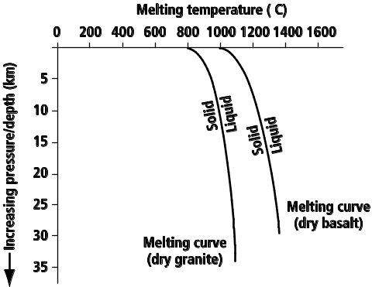
- How does pressure affect the melting point of rock?
____________________________________________________________________________________
- Do all minerals have the same melting point?
____________________________________________________________________________________
- How does temperature change with depth in Earth’s crust?
____________________________________________________________________________________
- How does pressure change with depth, and why?
____________________________________________________________________________________
In your textbook, read about how rocks melt.
Use each of the terms below just once to complete the passage.
elements | fractional crystallization | reverse
magma | melting points | partial melting
Because different minerals have different (16) ______________________ , not all parts of
a rock melt at the same time. The process whereby some minerals melt at low temperatures
while other minerals remain solid is called (17) ______________________. As each group of
minerals melts, different (18) ______________________ are added to the magma mixture
changing its composition. When the magma cools, it crystallizes in the (19) ______________________
order of partial melting. The process wherein different minerals form at different temperatures
is called (20) ______________________. As each group of minerals crystallizes, it removes
elements from the remaining (21) ______________________ instead of adding new elements.

SECTION 5.1 What are igneous rocks?, continued
In your textbook, read about Bowen’s reaction series.
22. _____________________
Label the diagram using either continuous reaction series or discontinuous reaction series.
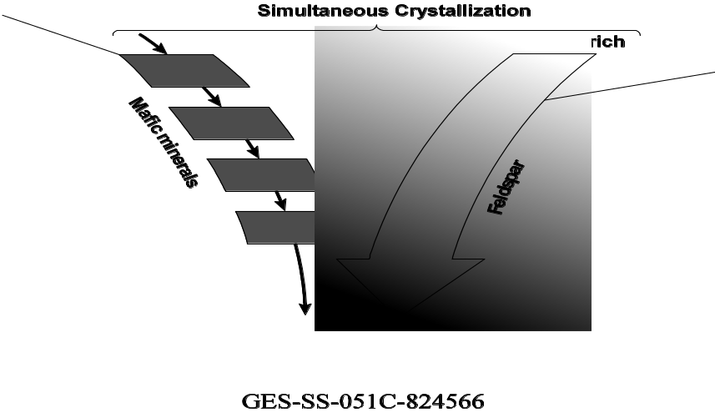
23. __________________
Answer the following questions. Use the diagram to answer Questions 24 and 25.
- The first feldspars to form are rich in what mineral?
____________________________________________________________________________________
- The second feldspars to form are rich in what mineral?
______________________________________________________________________________
- What causes a zoned crystal?
______________________________________________________________________________
______________________________________________________________________________
______________________________________________________________________________
- How is quartz formed?
______________________________________________________________________________
______________________________________________________________________________

SECTION 5.2 Classification of Igneous Rock
In your textbook, read about the mineral composition of igneous rocks.
Complete the table by filling in one of the following terms: granitic, basaltic, intermediate, or ultramafic.

Description | Type of Igneous Rock
1. May be formed by fractional crystallization of olivine and pyroxene
2. Contains moderate amounts of biotite, amphibole, and pyroxene
3. Light-colored, high silica content, contains quartz
4. Contains plagioclase, biotite, amphibole, pyroxene, and olivine
5. Peridotite and dunites are examples.
6. Dark-colored, low silica content, rich in iron and magnesium
7. Diorite in an example.
8. Gabbro is an example.
9. Granite is an example.
10. Low silica content, very high iron and magnesium content

In your textbook, read about the grain size of igneous rocks.
Answer the following questions.
- Does obsidian, a glassy rock, have a large grain size or a small grain size?
____________________________________________________________________________________
- Is obsidian an intrusive or extrusive igneous rock? How do you know?
____________________________________________________________________________________
____________________________________________________________________________________
- How does the texture of gabbro compare to that of obsidian?
____________________________________________________________________________________
____________________________________________________________________________________
- Is gabbro an intrusive or extrusive igneous rock? How do you know?
____________________________________________________________________________________
____________________________________________________________________________________

SECTION 5.2 Classification of Igneous Rocks, continued
In your textbook, read about classifying igneous rocks.
For each item in Column A, write the letter of the matching item in Column B.
Column A Column B
______ 15. Rock such as peridotite, which has low silica content and
very high levels of iron and magnesium
a. granitic
b. basaltic
c. ultramafic
d. porphyritic
e. pegmatite
f. kimberlite

______ 16. Rock with two different-sized grains of the same mineral
______ 17. Rock such as gabbro, which is dark-colored, has low
silica content, and is rich in iron and magnesium.
______ 18. Vein of extremely large-grained minerals
______ 19. Rare type of ultramafic rock that can contain diamonds
______ 20. Rock such as granite, which is light-colored and
has high silica content

In your textbook, read about the texture of igneous rocks.
Answer the following questions.
- Why do geologists make thin sections?
____________________________________________________________________________________
- Describe the differences in how an intrusive igneous rock and an extrusive igneous rock form.
____________________________________________________________________________________
____________________________________________________________________________________
- Why can minerals that form early in fractional crystallization grow distinct crystal shapes?
____________________________________________________________________________________
- What does a rock with a porphyritic texture look like?
____________________________________________________________________________________
____________________________________________________________________________________
- How do porphyritic textures form?
____________________________________________________________________________________
____________________________________________________________________________________

SECTION 5.2 Classification of Igneous Rocks, continued
In your textbook, read about igneous rocks as resources.
Circle the letter of the choice that best completes the statement or answers the question.
- Igneous rocks are strong because of their
a. temperature. c. water content.
b. color. d. interlocking grain textures.
- Which of the following is one of the most durable igneous rocks?
a. granite c. marble
b. sandstone d. limestone
- Igneous rocks tend to be
a. radioactive. c. resistant to weathering.
b. full of gold. d. vulnerable to weathering.
- Igneous intrusions often are associated with valuable
a. radioactive elements. c. oil reservoirs.
b. ore deposits. d. fossil deposits
- Ore deposits such as gold sometimes are found as a(n)
a. vein. c. obsidian deposit.
b. extrusion. d. molten rock.
- Metal-rich quartz veins are formed at the end of
a. volcanic eruptions. c. magma crystallization.
b. radioactive decay. d. the cooling of Earth’s crust.
- What are pegmatites?
a. veins of extremely large-grained minerals c. microscopic, interlocking crystal grains
b. magmas of differing densities d. small volcanoes
- What are kimberlites?
a. felsic rocks c. intermediate rocks
b. mafic rocks d. ultramafic rocks
- Diamonds can form only
a. under very low pressure. c. above ground.
b. under very high pressure. d. near radioactive elements.

