Vanessa M. Cordova
Mr. Drusky
APES 6th period
30 April 2013
Lyme Disease
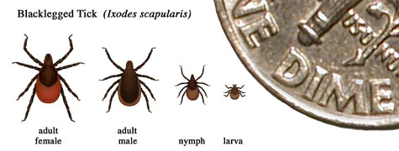
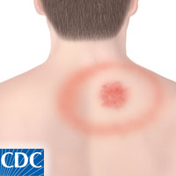

A non- communicable disease, Lyme disease is transmitted via tick bites from an infected backlegged tick, and can impact any body systems, though if left untreated, can escalate to the nervous system. The spirochete bacterium is carried by the backlegged tick, commonly knows as the deer tick in the United States. The ticks get the disease after they have fed on animals carrying it.
Lyme disease has the ability to impact any body system, though in the early stages, can look like the symptoms of strep throat. A person with lyme disease in an early stage will usually get a red rash, that gradually expands, be fatigued, have chills, headaches, muscle aches, and swollen lymph nodes. If left untreated, the symptoms can expand to Bell’s palsy, neck stiffness, and even heart palpitations. If caught early, this disease can be treated by antibiotics, though if it has progressed to impact the neurological system, and affect the heart, it is treated by drugs, like ceftriaxone and penicillin. Although lyme disease can be cured, some patients have recurring symptoms, Post- Treatment Lyme disease, though these symptoms, too, can be treated with antibiotics.
Not commonly requiring hospitalization, this disease usually only requires a few continuous doctor’s appointments to moniter treatment, and originally diagnose the disease. Though the patient may require a second opinion, wherein the cost would increase in order to go to a specialist.
Ticks prefer soft, easily accessible areas on organisms, in order to latch on. Therefore, in a tick prone area, people should amply cover up, and avoid wooded and bushy areas with high grass. Insect repellant spray can also repel ticks, and the chemical permethrin , also a tick repellant can be used on clothes, and remains on the clothes for various washes.
Primarily reported in 13 states in 2011, Lyme disease, it was still the most common Nationally Notifiable disease. Georgia was not one of those 13 states.

Works Cited

http://www.cdc.gov/lyme/

