AP CHEMISTRY –
SEMESTER 2
FINAL EXAM

Multiple Choice

- A flask contains 0.25 mol of SO_{2 (g)}, 0.50 mole of CH_{4 (g)}, and 0.50 mole of O_{2 (g)}. The total pressure of the gases in the flask is 800 mm Hg. What is the partial pressure of the SO_{2 (g)} in the flask?
- 800 mm Hg
- 600 mm Hg
- 250 mm Hg
- 200 mm Hg
- 160 mm Hg
- Under the same conditions of pressure, sulfur dioxide liquefies at a much higher temperature than carbon dioxide. Which best accounts for this difference?
  - Each sulfur dioxide molecule has a greater absolute volume than a carbon dioxide molecule.
  - Stronger forces of attraction exist between sulfur dioxide molecules than between carbon dioxide molecules.
  - S-O bonds illustrate resonance; C-O bonds do not.
  - Each carbon dioxide molecule has a greater molecular mass than a sulfur dioxide molecule.
  - At the same conditions of temperature and pressure, a sulfur dioxide molecule has greater density than a carbon dioxide molecule.
- The synthesis of nitrogen dioxide is represented by: 2 NO _{(g)} + O_{2 (g)} → 2 NO_{2 (g)}
A possible mechanism for the overall reaction represented above is the following:
(1) NO(g) + NO(g) → N₂O₂(g) slow
(2) N₂O₂(g) + O₂(g) → 2 NO₂(g) fast
Which of the following rate expressions agrees best with this possible mechanism?
  - Rate = k[NO]²
  - Rate = k[NO]²[O₂]
  - Rate = k[NO]
[O₂]
  - Rate = k[N₂O₂][O₂]
  - Rate = k[NO]²
[O₂]

- For which of the following processes would ∆S have a negative value?
I. 2 Fe₂O_{3 (s)} → 4 Fe _{(s)} + 3 O_{2 (g)}
II. Mg²⁺ _{(aq)} + 2 OH⁻ _{(aq)} → Mg(OH)_{2 (s)}
III. H_{2 (g)} + C₂H_{4 (g)} → 3 C₂H_{6 (g)}
  - I only
  - I and II only
  - I and III only
  - II only
  - I, II, and III

- The ground-state configuration of a negative ion of a halogen is represented by:
  - 1s² 2s²2p⁵ 3s²3p⁵
  - 1s² 2s²2p⁶ 3s²3p⁶
  - 1s² 2s²2p⁶2d¹⁰ 3s²3p⁶
  - 1s² 2s²2p⁶ 3s²3p⁶3d⁵
  - 1s² 2s²2p⁶ 3s²3p⁶3d³ 4s²

- At certain conditions, the molar volume of a real gas may be less than the value predicted by the ideal gas law. Which property accounts for this deviation?
  - Each gas molecule occupies an absolute volume.
  - Forces of attraction exist between the gas molecules.
  - Resonance bonds exist between the atoms in the molecules of the gas.
  - The average velocity of the gas molecules is less than the value predicted by Graham’s Law.
  - The kinetic energy of the gas molecules is less than the value predicted by the KE = 1/2mv².
- Appropriate uses of a visible-light spectrophotometer include which of the following?
I. Determining the concentration of a solution of Cu(NO₃)₂
II. Measuring the electrical conductivity of a solution of KMnO₄
III. Determining which ions are present in a solution that may contain Na⁺, Mg²⁺, Al³⁺
  - I only
  - II only
  - III only
  - I and II only
  - I and III only
- When a 1.25-gram sample of limestone was dissolved in acid, 0.44 gram of CO₂ was generated. If the limestone contained no carbonate other than CaCO₃, what was the percent of CaCO₃ by mass in the limestone?
  - 35%
  - 44%
  - 67%
  - 80%
  - 100%

- Refer to the reaction equation: HgO _{(s)} + 4 I⁻ _{(aq)} + H₂O _{(l)} ⇄ HgI₄²⁻ _{(aq)} + 2 OH⁻ _{(aq)} ∆H < 0
Consider the equilibrium above. Which of the following will increase the concentration of HgI₄²⁻ _{(aq)}?
  - Increasing the concentration of OH⁻ _{(aq)}
  - Adding 6 M HNO₃
  - Increasing the mass of HgO _{(s)} present
  - Increasing the temperature
  - Adding a catalyst

- For the underlined species in the reaction:
2 KMnO_{4 (aq)} + 3 H₂SO_{4 (aq)} + 5 H₂S _{(aq)} → 5 S _{(s)} + 2 MnSO_{4 (aq)} + K₂SO_{4 (aq)} + 8 H₂O _{(l)}
the oxidation number of sulfur changes from…
  - 0 to -2
  - +5 to -5
  - -2 to 0
  - -5 to 5
  - +6 to +4

- The graph below shows the titration curve that results when 100. mL of 0.0250 M acetic acid is titrated with 0.100 M NaOH.
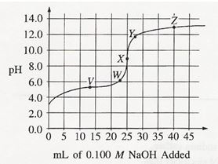
What part of the curve corresponds to the optimum buffer action for the acetic acid/acetate pair?
  - Point V
  - Point X
  - Point Z
  - Along all of section WY
  - Along all of section YZ

- Mixtures that would be considered buffers include which of the following?
I. 0.10 M HCl + 0.10 M NaCl
II. 0.10 M HF + 0.10 M NaF
III. 0.10 M HBr + 0.10 M HNO₃
  - I only
  - II only
  - III only
  - I and II
  - II and III

- One version of the First Law of Thermodynamics is expressed as ∆E = q + w.
Which gives the sign convention for this relationship that is usually used in chemistry?
Choices | heat, q, transferred to the system | heat, q, transferred to the surroundings | work, w done on the system | work, w done on the surroundings
A. | - | + | - | -
B. | + | + | + | +
C. | + | + | + | -
D. | + | - | + | -
E. | + | - | - | -

- The molecule of the following that has trigonal pyramidal geometry is:
  - CO₂
  - H₂O
  - CH₄
  - C₂H₄
  - PH₃

- The Lewis dot structure of which of the following molecules shows only one unshared pair of valence electrons?
  - Cl₂
  - N₂
  - NH₃
  - CCl₄
  - H₂O₂

- Ionization Energies for element X (kJ mol⁻¹)
First Second Third Fourth Five
580 1815 2740 11600 14800
The ionization energies for element X are listed in the table above. On the basis of the data, element X is most likely to be:
  - Na B. Mg C. Al D. Si E. P

- A sample of 0.010 moles of oxygen gas is confined at 127 °C and 0.80 atmospheres. What would be the pressure of this same sample at 27 °C and the same volume?
  - 0.10 atm
  - 0.20 atm
  - 0.60 atm
  - 0.80 atm
  - 1.1 atm

- When used to prepare a standard solution of acid with specified molarity, which apparatus provides the greatest precision for measuring the specified volume of solution to be prepared?
  - Eye dropper
  - Centigram balance
  - Dewar flask
  - Erlenmeyer flask
  - Volumetric flask

- The net ionic equation for the reaction that occurs during the titration of nitrous acid with sodium hydroxide is:
  - HNO_{2 (aq)} + Na⁺ _{(aq)} + OH⁻ _{(aq)} → NaNO_{2 (aq)} + H₂O _{(l)}
  - HNO_{2 (aq)} + NaOH _{(aq)} → Na⁺ _{(aq)} + NO₂⁻ _{(aq)} + H₂O _{(l)}
  - H⁺ _{(aq)} + OH⁻_{(aq)} → H₂O _{(l)}
  - HNO_{2 (aq)} + H₂O _{(l)} → NO₂⁻ _{(aq)} + H₃O⁺ _{(aq)}
  - HNO_{2 (aq)} + OH⁻ _{(aq)} → NO₂⁻ _{(aq)} + H₂O _{(l)}

- Refer to the balanced chemical reaction: 2 A _{(g)} + B _{(g)} ⇄ 2 C _{(g)}
When the concentration of substance B in the reaction above is doubled, all other factors being held constant, it is found that the rate of the reaction remains unchanged. The most probable explanation for this observation is that…
  - the order of the reaction with respect to substance B is 1.
  - substance B is not involved in any of the steps in the mechanism of the reaction.
  - substance B is not involved in the rate-determining step of the mechanism, but is involved in subsequent steps.
  - substance B is probably a catalyst, and as such, its effect on the rate of the reaction does not depend on its concentration.
  - the reactant with the smallest coefficient in the balanced equation generally has little or no effect on the rate of the reaction.

- The isomerization of cyclopropane to propylene is a first-order process with a half-life of 19 minutes at 500 °C. The time it takes for the partial pressure of cyclopropane to decrease from 1.0 atmosphere to 0.125 atmospheres at 500 °C is closest to…
  - 38 minutes
  - 57 minutes
  - 76 minutes
  - 152 minutes
  - 190 minutes

- Energy is added to a system containing a pure substance at a constant rate as shown in the heating curve below:
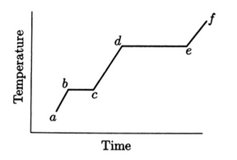
Which accounts for the difference in length of the line segments b - c and d - e?
  - The heat of fusion is less than the heat of vaporization.
  - The heat of fusion is greater than the heat of vaporization.
  - The solid has a greater specific heat capacity than the liquid.
  - The liquid has a greater specific heat capacity than the solid.
  - The heat of sublimation is equal to the sum of the heats of fusion and vaporization.

For questions 23-26 please refer to the electrochemical cell represented below using the following reduction half-reactions and their Eº values:

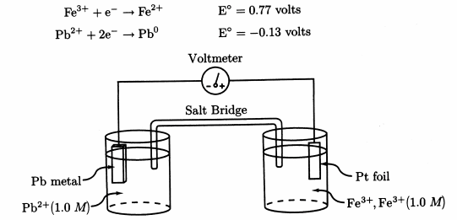
- Which describes change in concentration for Pb²⁺ and the movement of charge in this electrochemical cell as the cell undergoes discharge?
movement of electrons movement of positive ions change in [Pb²⁺]
in the external circuit in the salt bridge
  - toward the cathode toward the cathode increases
  - toward the anode toward the anode increases
  - toward the cathode toward the anode decreases
  - toward the anode toward the cathode decreases
  - toward the cathode toward the anode increases

- Which expression gives the change in mass expected at the lead electrode after this cell has produced 150 milli-amps for 2.0 hours?
  - 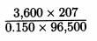 B. 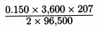 C. 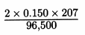

  - 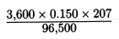 E. 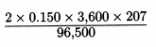
- Which expression gives the voltage for this standard chemical cell?
  - 0.13 + 0.77 volts
  - -0.13 + 0.77 volts
  - 0.13 + (2 x 0.77) volts
  - (2 x 0.13) + (2 x 0.77) volts
  - (2 x (-0.13)) + (2 x 0.77) volts
- A similar electrochemical cell is assembled using standard electrodes except that the concentration of Pb²⁺ is changed to 0.010 M. Which is the best comparison of the voltage of the original standard cell to this non-standard cell?
  - No difference is expected.
  - The voltage of the non-standard cell is greater than that of the standard cell.
  - The voltage of the non-standard cell is less than that of the standard cell.
  - The voltage of the non-standard cell drops to zero.
  - It is impossible to determine the effect of changing concentration on voltage.

- Which is an example of a p-type semiconductor; that is, a semiconductor; that is, a semiconductor in which a transport of charge is produced by moving spaces that accommodate valence electrons?
  - arsenic with some silicon added
  - germanium with some silicon added
  - silicon with some gallium added
  - silicon with some germanium added
  - germanium with some arsenic added

- Resonance helps to account for all of the following properties EXCEPT
  - the equal S-O bond energies in SO₂
  - the bond order of 1.5 for ozone (O₃)
  - the charge of 3+ on the aluminum ion, Al³⁺
  - the equal bond strengths in the nitrate ion, NO₃¹⁻
  - the equal bond lengths in the carbonate ion, CO₃²⁻

- At 298 K, as the salt MX dissolves spontaneously to form an aqueous solution, ∆S and ∆H are positive. Which describes the value of ∆G and the absolute values of its components, T∆S and ∆H?
  - ∆G < 0; IT∆SI > I∆HI
  - ∆G < 0; IT∆SI < I∆HI
  - ∆G > 0; IT∆SI > I∆HI
  - ∆G > 0; IT∆SI < I∆HI
  - ∆G = 0; IT∆SI = I∆HI

- The molar solubility of Ag₂CrO_{4 (s)} is 1.3 x 10⁻⁴ mol L⁻¹ for: Ag₂CrO_{4 (s)} ⇔ 2 Ag⁺_{(aq)} + CrO₄²⁻_{(aq)}
Which expression gives the value for K_{sp}, the solubility product constant?
  - (1.3 x 10⁻⁴)(1.3 x 10⁻⁴)²
  - (2.6 x 10⁻⁴)² (1.3 x 10⁻⁴)
  - (2.6 x 10⁻⁴)(1.3 x 10⁻⁴)
  - 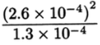
  - 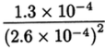

- Four trials of the reaction below were carried out in order to determine its rate law.
2 A + B + C → Products
The following data were collected:
Trial | [A] | [B] | [C] | Initial Rate  M sec¹⁻
1 | 0.02 | 0.02 | 0.02 | 1.6 x 10⁻³
2 | 0.01 | 0.02 | 0.02 | 8.0 x 10⁻⁴
3 | 0.01 | 0.04 | 0.02 | 1.6 x 10⁻³
4 | 0.01 | 0.04 | 0.03 | 1.6 x 10⁻³

Based on these observations, what is the rate law?
- Rate = k[A]²
- Rate = k[B][C]
- Rate = k[A][B]
- Rate = k[A]²[B]²
- Rate = k[A]²[B][C]

- Which properties must be known in order to use a constant-pressure (“coffee cup”) calorimeter to investigate heats of reaction?
i. The initial temperature of the solution
ii. Heat capacity of the solution, c_{sol’n}
iii. Mass of solution

  - I only
  - II only
  - III only
  - I and III only
  - I, II, and III

- According to the Kinetic Molecular Theory, all of the following apply to a mixture of gases EXCEPT
  - All gas molecules travel at the same speed
  - The collisions of the gas molecules are perfectly elastic
  - The forces of attraction between the gas molecules are negligibly small
  - The gas molecules exert pressure on the wall of the container of the system
  - Compared to the volume of the system, the absolute volume of the gas molecules is negligibly small.

- Refer to the mass spectrometry diagram below:
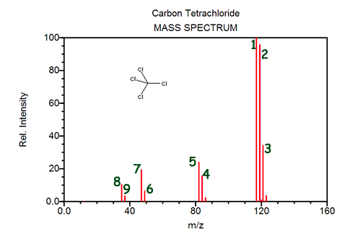
Peaks 8 and 9 are representative of...
  - chlorine’s electron configuration
  - two isotopes of carbon
  - chlorine’s existence as a diatomic molecule
  - two isotopes of chlorine

- Use the thermochemical equations shown below to determine the enthalpy for the reaction:
P_{4 (s)} + 10 Cl_{2 (g)} → 4 PCl_{5 (g)}
________________________________________________________________________
4 PCl_{3 (g)} → P_{4 (s)} + 6 Cl_{2 (g)} ∆H = 1626.0 kJ
PCl_{3 (g)} + Cl_{2 (g)} → PCl_{5 (g)} ∆H = -166.5 KJ
The enthalpy for the reaction (in kJ) is…
  - - 2292.0 kJ
  - - 1792.5 kJ
  - 1459.5 kJ
  - 1792.5 kJ
  - 2292.0 kJ

- Refer to the PES spectrum below for the following question:
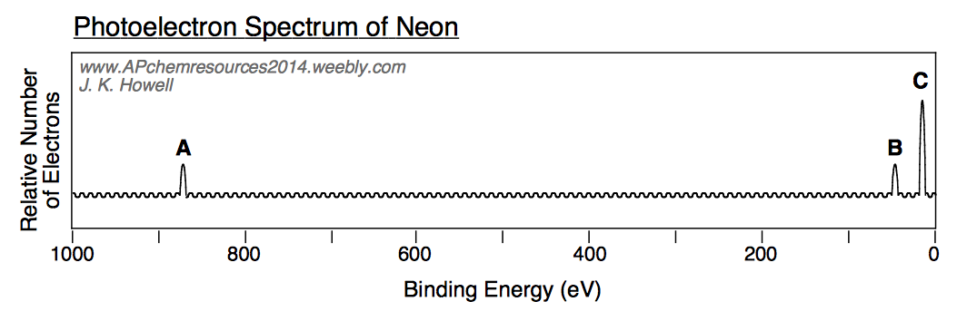
Which of the following statements best accounts for peak A being far to the left of peaks B and C:
  - the electron configuration of neon is 1s²2s²2p⁴
  - neon has 8 electrons located in its valence shell
  - core electrons of an atom experience a much higher effective nuclear charge than valence electrons
  - peaks B and C show first ionization energies of electrons in neon, whereas peak A shows the second ionization energy of neon electrons
  - peak A is the only peak that truly applies to neon

- A compound consists of the following elements by percent by mass:
sulfur - 50%
oxygen - 50%
The ratio of sulfur : oxygen : hydrogen in the empirical formula is:
  - 1 : 1 b. 1 : 2 c. 2 : 1 d. 2 : 3 e. 3 : 2

- Refer to the statements below:
i. Electrons follow distinct pathways around the nucleus.
ii. The location of electrons cannot readily be determined.
iii. The atom is an overall positively charged mass with negative particles randomly
dispersed throughout it.
Which of the statements listed above best applies to the Bohr Model of the atom?
  - i only
  - ii only
  - i and iii
  - ii and iii
  - i, ii, and iii

- The synthesis of nitrogen dioxide follows the reaction:
2 NO _{(g)} + O_{2 (g)} → 2 NO_{2 (g)}
A sealed rigid container initially holds 6 mol of NO _{(g)} and 5 mol O_{2 (g)}. Assuming 1 particle represents 1 mole of a substance, which picture correctly depicts the interior of the container once the reaction has gone to completion? (dark circles represent nitrogen atoms, light circles represent oxygen atoms)
  - 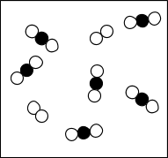 B. 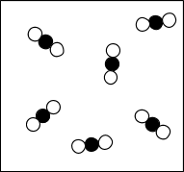

C. 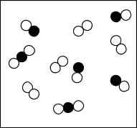 D. 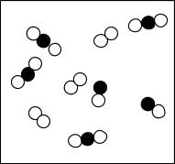

E. 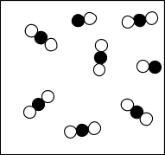

- The melting point of magnesium sulfide is 2000 ºC, whereas the melting point of sodium bromide is 747 ºC. This can be explained by the fact that…
i. Mg has a charge of 2+, wheres Na has a charge of 1+
ii. Mg²⁺ has a smaller radius than Na¹⁺
iii. S²⁻ has a larger radius than Cl¹⁻
  - i only
  - ii only
  - i and ii
  - i and iii
  - i, ii, and iii

- For the reaction: C _{(s)} + O_{2 (g)} → CO_{2 (g)} the ∆H = -393.5 kJ/mol; however, this reaction does not occur spontaneously. What statement best explains this?
  - The reaction has a positive entropy value.
  - The reaction has a low activation energy.
  - The reaction has a high activation energy.
  - The reaction involves an inert solid.
  - The reaction has a negative ∆G.

- Which of the pictures below best displays the hydrolysis of magnesium chloride? (Ions are drawn according to their appropriate relative size ratios.)
  - 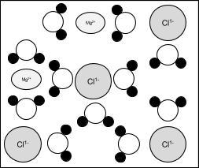 B. 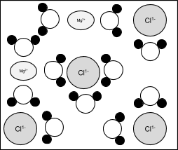

C. 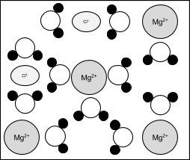 D. 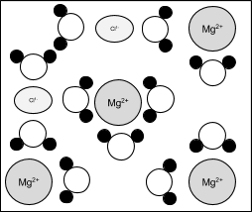

- A chemical reaction is determined to be second order. Which of the following graphs would validate this conclusion?
  - 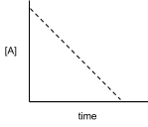 B. 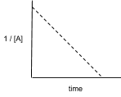 C. 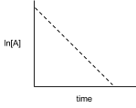

D. 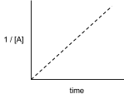 E. 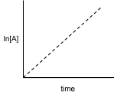

- A solution should be prepared to buffer at a pH of 2.4. Which of the acid / salt pairs should be used to prepare a buffer for this system?
  - CH₂ClCOOH / NaCH₂ClCOO (k_{a} = 1.4 x 10⁻³)
  - C₆H₅COOH / KC₆H₅COO (k_{a} = 6.5 x 10⁻⁵)
  - HClO / NaClO (k_{a} = 3.5 x 10⁻⁸)
  - H₂O₂ / NaHO₂ (k_{a} = 2.4 x 10⁻¹²)

- The diagram below represents a Boltzmann distribution for Argon at 300 K:
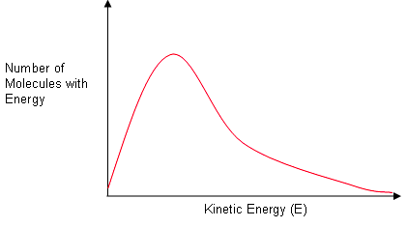
Which of the dotted line spectra would represent the distribution for Argon at 400 K?
  - 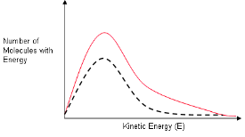 b. 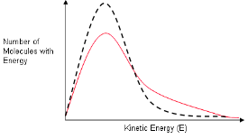

c. 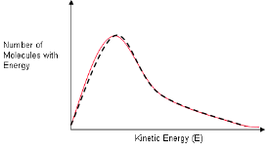 d. 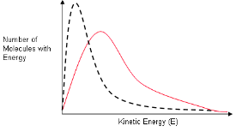

e. 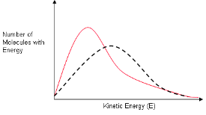
- Refer to the graph below for the reaction: A _{(g)} ⇔ B _{(g)}
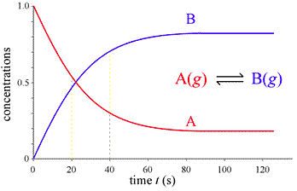
At what time does the reaction first reach equilibrium?
  - 20 seconds
  - 40 seconds
  - 60 seconds
  - 80 seconds
  - 100 seconds

- For a given reaction, ∆H = -60.0 kJ/mol and ∆S = -20.0 J/K-mol. The reaction will have ∆G = 0 at ________ K. (Assume that ∆H and ∆S do not vary with temperature.)
  - 0.003 B. 3 C. 300 D. 333 E. 3000

- Which pair of solutions, when mixed, will produce a white precipitate?
  - AgNO₃ _{(aq)} + NaCl _{(aq)}
  - AgNO_{3 (aq)} + K₂CrO_{4 (aq)}
  - AgNO_{3 (aq)} + KMnO_{4 (aq)}
  - Mn(NO₃)₂ _{(aq)} + Na₂S _{(aq)}
  - AgNO_{3 (aq)} + Na₂S _{(aq)}

- A sample of SiC is viewed at the molecular level. Which of the following pictures would look most like the sample of SiC?
  - 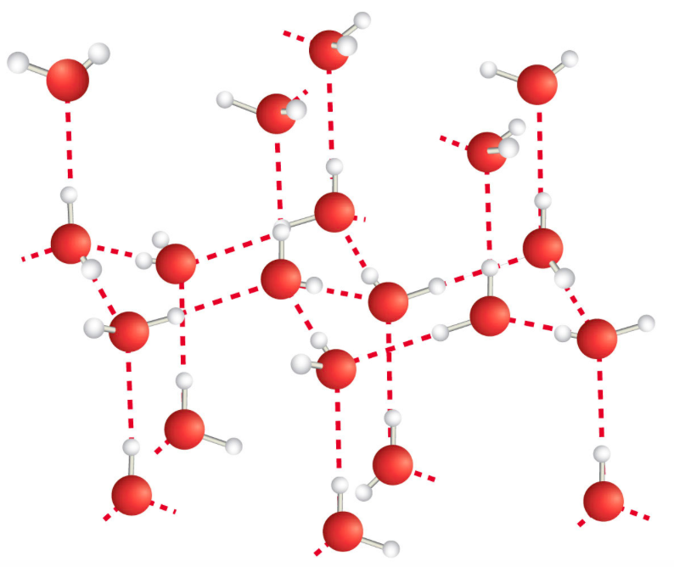 B. 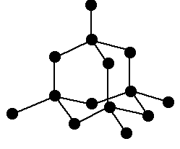

C. 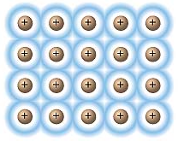 D. 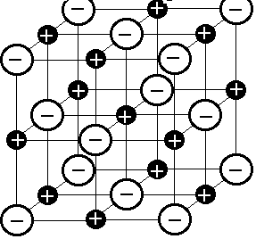

- Refer to the following substances:
X = CH₃-CH₂-CH₂-CH₂-CH₃ Y = CH₃-CH₂-CH₂-CH₂-OH Z = HO-CH₂-CH₂-CH₂-OH
Based on concepts of polarity and hydrogen bonding, which of the following sequences correctly lists the compounds above in the order of their increasing solubility in water?
  - Z < Y < X b. Y < Z < X c. Y < X < Z d. X < Z < Y e. X < Y < Z

- Which of the following must be true for a reaction that proceeds spontaneously to form products from initial standard state conditions?
  - ∆G° > 0 and K_{eq} > 1
  - ∆G° > 0 and K_{eq} < 1
  - ∆G° < 0 and K_{eq} > 1
  - ∆G° < 0 and K_{eq} < 1
  - ∆G° = 0 and K_{eq} = 1

- Refer to the bond length diagram for ethene: H₂C=C₂H
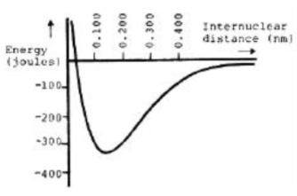
Which of the following diagrams (dotted line) would apply to ethyne (triple-bonded carbons)?
  - 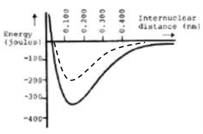 B. 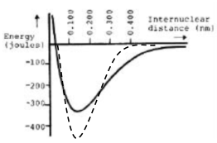

C. 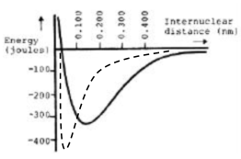 D.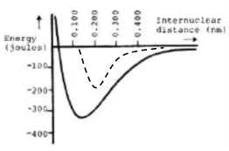

- Which of the following bonds is most polar?
  - N - Cl B. C - N C. S - S D. Br - Br E. S - O

- A 30.0 mL aliquot of HCl is titrated using 0.15 M NaOH.The titration curve provided by the reaction and a pH probe yielded the graph below. What would be the molarity of the HCl solution?
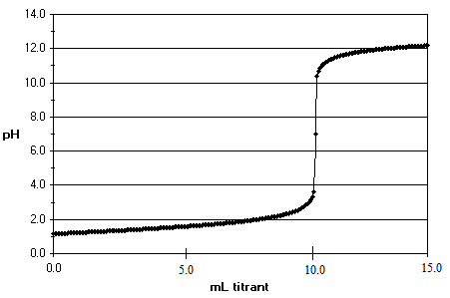
  - 0.050 M HCl
  - 0.10 M HCl
  - 0.15 M HCl
  - 0.30 M HCl
  - 0.45 M HCl

- The following pictures represent acids: HA, HB, HC, HD. Based on the dissociation shown below, which of the acids displayed is the strongest acid?
  - 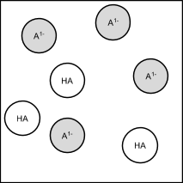 B. 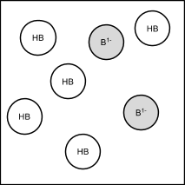

C. 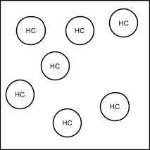 D. 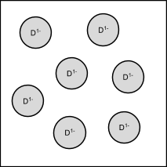

- What distance corresponds to the activation energy for the reaction of X to Y?
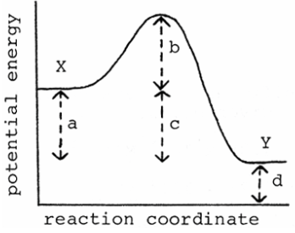
  - a B. b C. c D. d E. e

- Which k expression best describes the hydrolysis of NaCN?
  - $\frac{\left[HCN\right][NaOH]}{\left[NaCN\right][H_{2}O]}$
  - $\frac{\left[HCN\right][{OH}^{-}]}{\left[{CN}^{-}\right][H_{2}O]}$
  - $\frac{\left[HCN\right][{OH}^{-}]}{\left[{CN}^{-}\right]}$
  - $\frac{\left[H^{+}\right][{OH}^{-}]}{[H_{2}O]}$
  - $\frac{\left[H{Na}^{+}\right][H_{3}O^{+}]}{[H_{2}O]}$

- The Ksp of lead (II) iodide is 7.1 x 10⁻⁹. The concentration of the [Pb²⁺] and [I¹⁻] are both 2.0 x 10⁻³ M. Which direction will the reaction shift and will a precipitate form?
  - The reaction will shift left and a precipitate will form.
  - The reaction will shift left and a precipitate will not form.
  - The reaction will shift right and a precipitate will form.
  - The reaction will shift right and a precipitate will not form.
  - The reaction will NOT shift because it is at equilibrium.

- Why does atomic radius decrease as you move across a period of the periodic table from left to right as it goes from one element to the next?
  - because the increasing number of protons and decreasing number of electrons creates an attractive force which causes the atom to expand
  - because the increasing number of protons and increasing number of electrons creates an attractive force which causes the atom to shrink in on itself
  - because the decreasing number of protons and decreasing number of electrons creates an attractive force which causes the atom to shrink in on itself
  - because the decreasing number of protons and increasing number of electrons creates an attractive force which causes the atom to shrink in on itself
  - None of the above

- Thin layer chromatography was used to separate unknowns in a liquid mixture. The mobile phase was a nonpolar liquid. Their respective retention factors are listed in the table below:
Unknown | Retention Factor (R_{f})
U₁ | 0.45
U₂ | 0.77
U₃ | 0.12
U₄ | 0.64
Which of the substances was the most polar?
  - U₁
  - U₂
  - U₃
  - U₄
  - All of the substances had the same degree of polarity.

MULTIPLE CHOICE RESPONSES

1
2
3
4
5
6
7
8
9
10
11
12
13
14
15
16
17
18
19
20
21
22
23
24
25
26
27
28
29
30

31
32
33
34
35
36
37
38
39
40
41
42
43
44
45
46
47
48
49
50
51
52
53
54
55
56
57
58
59
60

FREE RESPONSE

- Answer the following questions about the analysis of iron-containing compounds using potassium permanganate solution.
  - Write the balanced equation in ACID solution for the reaction below:
Fe²⁺ + MnO₄¹⁻ → Fe³⁺ + Mn²⁺

  - To standardize a potassium permanganate solution, a 0.250 g sample of FAS (iron (II) ammonium sulfate hexahydrate; molar mass: 342 g) is dissolved in 25.00 mL distilled water, then acidified with sulfuric acid. The solution is then titrated with 35.00 mL potassium permanganate solution from a burette until a pale persistent purple color is attained. Calculate the molarity of the potassium permanganate solution.

  - The standardized potassium permanganate solution is then used to titrate a solution made by dissolving a 0.500 g sample of a mixture of iron (II) sulfate and sodium sulfate in 50.00 mL dilute sulfuric acid. A total of 10.21 mL of potassium permanganate solution is required to reach the pale purple endpoint. What is the mass percent of iron (II) sulfate in the original mixture?

  - Would would the effect, if any, on the value for the reported standard molarity of potassium permanganate if the following errors were made? Explain each of your three answers.
    - Some drops of water remained in the burette after cleaning but before the permanganate solution was added to the burette.

    - The student neglected to run some permanganate solution through the tip of the burette before taking the initial reading.

    - The student’s lab partner spilled some FAS after weighing it but before titration.

- Periodic Relationships
  - Ionization Energies, (kJ / mol)
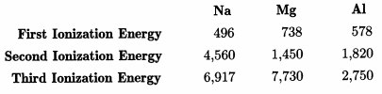
    - The second ionization for each element is greater than the first ionization energy for that element. Explain.

    - The difference between the first and second ionization energies is much greater for Na than for Mg. Explain.

  - Atomic / Ionic Radius, (nm)
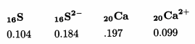
    - The radius of ₁₆S is less than the radius of ₁₆S²⁻. Explain.

    - The ₁₆S²⁻ and ₂₀Ca²⁺ are isoelectronic species. However, the radius of ₁₆S²⁻ is greater than the radius of ₂₀Ca²⁺. Explain.

- Answer all four questions about the burning of octane.
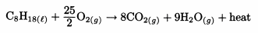
The combustion reaction above is the source of the energy produced by the burning of octane in an automobile engine. This reaction is spontaneous at 298 K.
  - Predict the sign of ∆S in the reaction. Explain.

  - Predict the sign of ∆G for this reaction at 298 K. Explain.

  - ∆Hº_{f, CO2 (g)} = -393.5 kJ/mol; ∆Hº_{f, CO (g)} = -110.5 kJ/mol
If some of the reactants were converted to CO rather than CO₂, how would the total amount of energy produced be affected? Explain.

  - If this reaction were carried out at a temperature greater than 298 K, for which of the three parameters, ∆H, ∆G, or ∆S, would the change in value have the greatest magnitude? Explain.

- Answer the following questions about a chromium/hydrogen electrochemical cell.
  - Make a labeled sketch of an electrochemical cell using a standard Cr/Cr³⁺ half cell connected to a standard hydrogen half-cell. Your labels should include:
    - anode
    - cathode
    - chemical components and concentration(s) in the chromium half cell
    - direction of electron flow in the external circuit
    - path for ion migration

  - Write the half reactions and the balanced overall equation for this cell.

  - Calculate the voltage for this standard cell.

  - Calculate the voltage when the concentration of Cr³⁺ is 0.050 M.

- Methylamine, CH₃NH₂, is an organic base, accepting a proton from water to form the methylammonium ion. The value of K_{eq} for this system is 4.0 x 10⁻⁴ at 298 K.
  - Write the chemical equation for the equilibrium as described above.

  - Calculate the concentration of hydroxide ions in a 0.25 M solution of methylamine.

  - How is the equilibrium affected when solid NaOH is added to a solution of methylamine? Calculate the [CH₃NH₃¹⁺] when 0.020 mol OH¹⁻ is added to 500. mL of 0.25 M methylamine, CH₃NH₂. (Assume no change in volume.)

  - A buffer solution is prepared that is 0.20 M in CH₃NH₃¹⁺ and 0.25 M in CH₃NH₂. Calculate the pH of this solution.

  - Calculate the number of moles of H¹⁺ that must be added to 200. mL of the solution in part (d) in order to change the pH to 10.00.

- Refer to the reaction and data table below:
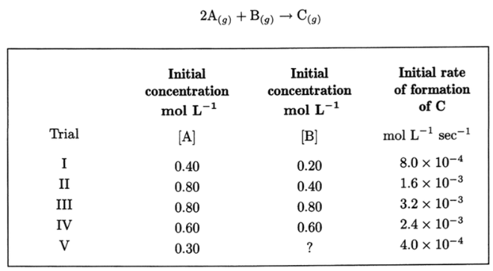
  - Write the rate law for the reaction above in the form Rate = k[A]^{x}[B]^{y} including numerical values for x and y. Explain how you determined the values for exponents x and y.

  - Calculate the specific rate constant, k. Specify the units for k.

  - Calculate the rate of formation of C in trial IV after [A] has decreased to 0.30 M.

  - Calculate the initial concentration of reactant B in trial V.

  - If the temperature were raised by 10ºC for any trial, what would be the effect on the initial rate of formation for C? Explain.

- Use principles of the Kinetic Molecular Theory to respond to the questions below.
  - In the space below, complete the sketches of two pistons to represent samples containing 1.60 g of the gas specified in 0.5 liters at 298 K. Each piston should be similar to the example shown.
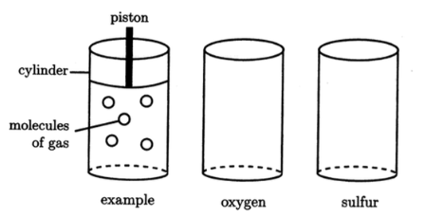
  - Compare the average kinetic energy of each sample. Explain.

  - Compare the average molecular velocity for each sample. Explain.

  - Compare the pressure for each sample. Explain.

- Using principles of chemical bonding and/or intermolecular forces, explain each of the following.
  - The normal boiling point of iodine, I₂, is greater than the normal boiling point of chlorine, Cl₂.

  - Both Ag _{(s)} and molten Ag are excellent conductors of electricity. However, silver nitrate, AgNO₃, is a good conductor only when melted or dissolved in water. As a solid, it is a poor conductor of electricity.

  - The normal boiling point of H₂O is higher than the normal boiling point of H₂S even though the molar mass of H₂O is less than the molar mass of H₂S.

  - Arsenic, As, reacts with the metal sodium, Na, to form Na₃As. Arsenic reacts with the nonmetal chlorine, Cl₂, to form AsCl₃.

