Spinal Meningitis
Spinal Meningitis is a communicable disease that affects the brain, nerves and spinal cord.
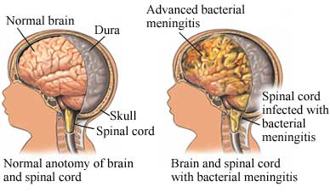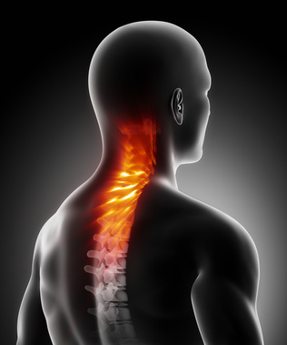
Causes
Bacterial or Viral cause this and symptoms are not easily noticed. Spinal Meningitis can be transferred through contact with an infected person and is also contagious through Saliva, Nasal productions, being over friendly allowing people to use personal items, through contact such as liplocking and becoming too comfortable and sitting on public restrooms toilet seats. Spinal Meningitis is also popularly transferred in areas such as daycares, dormitories, classroom and households where beds and other sitting areas are shared.
Symptoms
- Headache
- Stiff neck
- Sleepiness or Confusion
- Sensitivity to bright light
- Nausea

Treatment
There is no known cure to prevent spinal meningitis; however patients are given IV fluid, scans and a spinal tap. A variety of antibiotics are also given to cancel out the headache and other symptoms, this immediate treatment can prevent fatality.
Cost
The total cost of any meningitis treatment is 21,841 dollars total. The hospital cost is 2,043 and the treating cost is a range from 60-190 dollars.
Prevention
There is a shot that is able to be taken to prevent obtaining this disease. Also being cleanly and disinfecting surfaces so no germs will spread.
Stats and Facts
- Spinal Meningitis can be fatal and cause lasting brain damage effects if survived.
- It is a Bacterial infection and is also known as Bacterial Meningitis.
- Spinal Meningitis is an infection of layers called meninges in the brain that is acute.
- Can cause death within hours if not treated

http://www.lifescript.com/health/centers/asthma/related_conditions/bacterial_meningitis.aspx?gclid=CMnHiKSb9rYCFcud4Aod93sA4w&ef_id=UWr1ygAAACLmSjWc:20130502005631:s
http://www.meningitis.org/symptoms?gclid=CJ6wr7Gj9rYCFUFo4Aod_nAA2Q
http://www.cedars-sinai.edu/Patients/Health-Conditions/Spinal-Meningitis.aspx

