The History of Astronomy
WebQuest

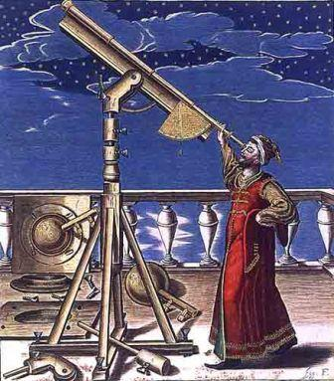

Introduction:

Astronomy is the scientific study of matter in outer space, especially the positions, dimensions, distribution, motion, composition, energy, and evolution of celestial bodies and phenomena.
In this WebQuest you are going to look at some of the ideas, people, and technology that have helped to add to our collective understanding of the Universe.

Please answer each question on separate sheet of paper. Use the websites provided or another of your choosing to answer the questions. If one of the provided links doesn’t work, use another source.

Websites:
Top 10 Important Astronomers
Famous People in Astronomy
7 Astronomers You Should Know
List of Astronomers
Famous Astronomers
The Process:

- Ancient Astronomers: The following astronomers/scientists all played a significant role in advancing our understanding of the cosmos during early civilization. Using the following sites, or one of your own, write a brief description about the time period during which the person lived, where they lived, their contributions to astronomy, and what you think about their accomplishments. All answers should be written directly beneath the name of the astronomer and written in complete sentences.

People:
Eratosthenes
Aristotle
Aristarchus
Ptolemy

- Renaissance Astronomers: The following astronomers/scientists all played a significant role in advancing our understanding of the cosmos during early civilization. Using the following sites, or one of your own, write a brief description about the time period during which the person lived, where they lived, their contributions to astronomy, and what you think about their accomplishments. All answers should be written directly beneath the name of the astronomer and written in complete sentences.

People:
Nicolaus Copernicus
Tycho Brahe
Johannes Kepler
Galileo Galilei
William Herschel
Isaac Newton

- Modern Astronomers: The following astronomers/scientists all played a significant role in advancing our understanding of the cosmos during early civilization. Using the following sites, or one of your own, write a brief description about the time period during which the person lived, where they lived, their contributions to astronomy, and what you think about their accomplishments. All answers should be written directly beneath the name of the astronomer and written in complete sentences.

People:
Maria Mitchell
Henrietta Swan Leavitt
Edwin Hubble
Albert Einstein
Carl Sagan
Stephen Hawking

- Our understanding of the cosmos and the objects in it has evolved over many thousands of years. Ideas about stars, planets, moons, and even our own importance in the universe have been revised again and again throughout history. Below are some concepts and ideas that astronomers once believed or still believe. Please use the provided websites, or websites of your own choosing, to write a few sentences about each. Your answer should describe what the idea is, when it was first put forth, who first presented the idea, and whether or not we still believe the concept to be true. If the idea is no longer valid than please tell me what is currently the accepted theory.
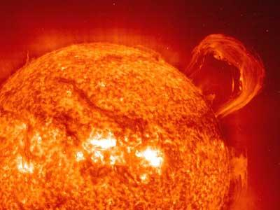

Websites:
Outdated Astronomical Theories
Why Are There Seasons
There’s No Gravity in Space
Important Astronomers
Astronomy Misconceptions

Concepts/Ideas:
Geocentric Theory
Heliocentric Theory
Steady State Universe
Big Bang Theory
There’s no gravity in space
Hubble’s Law
Retrograde Motion
Drake Equation
Space is inflexible

- The Uses of Astronomy: Describe how the constellations were first perceived and how their role changed over time. Also, describe the role of constellations in navigation past and present.

- Explain how modern astronomy benefits society today. The main points should be how the Sun affects communication, navigation and high-tech devices (Hint: CME’s). Also, explain how astronomy aids in the tracking of near-earth objects.

