Unit 7: Energy in Reactions
Honors Chemistry Assignments and Objectives

Part I – Calculating Energy/Heat
Must show all work, units, significant figures for full credit. Circle/Box answer.
1. If the temperature of 34.4 g ethanol increases from 25.0ºC to 78.8ºC, how much heat has been absorbed by the ethanol? The specific heat of ethanol is 2.44 J/gºC

2. A 155-g sample of an unknown substance was heated from 25.0ºC to 40.0ºC. In the process, the substance absorbed 5696 J of energy. What is the specific heat of the substance?

- If 335 g of water at 65.5°C loses 9750 J of heat, what is the final temperature of the water?

- The temperature of a sample of water increases from 20.0°C to 46.6°C as it absorbs 5650 J of heat. What is the mass of the sample?

- A small pebble with a specific heat of 0.254 J/g °C is heated in a boiling water bath that is 100.0°C and placed in a calorimeter containing 25.0 mL of water at 25.0°C. The water reaches a maximum temperature of 26.4°C.
- How many joules of heat were released by the pebble?

- What is the mass of the pebble?

Part II: Reaction Diagrams and Thermochemical Equations
Use the diagram below to answer questions 1-5.

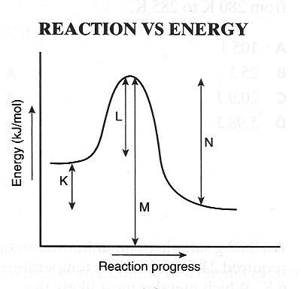
1.Which letter represents the activation energy for the reaction?

2.Which letter represents the enthalpy change for the reaction?

3.Is the reaction in the diagram exothermic or endothermic?

4.Is the enthalpy change positive or negative?

5.Is heat energy absorbed or released?

6.How much heat will be released when 6.44 g of sulfur reacts with excess O₂ according to the following equation?
2S + 3O₂ → 2SO₃ ΔH = -791.4 kJ

7.How much heat will be released when 4.72 g of carbon reacts with excess O₂ according to the following equation?
C + O₂ → CO₂ ΔH = -393.5 kJ

8.How much heat will be absorbed when 38.2g of bromine reacts with excess H₂ according to the following equation?
H₂ + Br₂ → 2HBr ΔH = 72.80 kJ

Part III: Heating/Cooling Curves
- Use the heats of fusion and heats of vaporization to calculate heat lost or gained during phase changes.
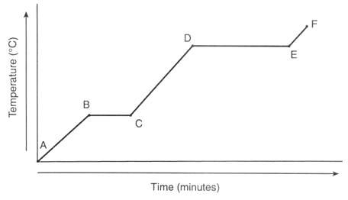

- Label the heating curve above with the state of matter that exists in each segment.
- Label the heating curve above with the equation that would be used to calculate the quantity of heat absorbed within each segment.
- Which segments above involve an increase in kinetic energy?

- Which segments above involve an increase in potential energy?

5. How much heat is required to warm 225 g of ice from -46.8ºC to 0.0ºC, then melt the ice, then warm the water from 0.0ºC to 100.0ºC, then boil the water, then heat the steam to 173.0ºC? Note—You must calculate the heat required for each of the five sections of the heating curve, then add all values for the total heat required. Use correct units!

Part IV: Calculating Enthalpies

- From the following enthalpy changes:
4NH₃ (g) + 5O₂ (g) → 4 NO (g) + 6H₂O (l) ∆H° = -1170 kJ
4NH₃ (g) + 3O₂ (g) → 2N₂ (g) + 6H₂O (l) ∆H° = -1530kJ
calculate the value of ∆H° for the reaction N₂ (g) + O₂ (g) → 2NO (g).

- Find the ΔH for the reaction below, given the following reactions and subsequent ΔH values: H₂SO₄(l) → SO₃(g) + H₂O(g)
H₂S(g) + 2O₂(g) → H₂SO₄(l) ΔH = −235.5 kJ
H₂S(g) + 2O₂(g) → SO₃(g) + H₂O(l) ΔH = −207 kJ
H₂O(l) → H₂O(g) ΔH = 44 kJ

- Find the ΔH for the reaction below, given the following reactions and subsequent ΔH values: N₂H₄(l) + CH₄O(l) → CH₂O(g) + N₂(g) + 3H₂ (g)
2NH₃(g) → N₂H₄(l) + H₂(g) ΔH = 22.5 kJ
2NH₃(g) → N₂(g) + 3H₂(g) ΔH = 57.5 kJ
CH₂O(g) + H₂(g) → CH₄O(l) ΔH = 81.2 kJ

2. Use the standard enthalpies of formation to calculate Hº_{rxn} for each of these reactions.

Compound/Element | Hº_{f kJ/mol}
H₂ (g) | 0
O₂ (g) | 0
H₂ O (g) | -242
H₂ O₂ (l) | -188
NH₃ (g) | -46
NH₄Cl (s) | -314
HCl (g) | -92
FeS (s) | -102
Fe₂ O₃ (s) | -824
SO₂ (g) | -297
NaHCO₃ (s) | -951
Na₂ CO₃ (s) | -1131
CO₂ (g) | -394
H₂ S (g) | -21

- 2NaHCO₃ (s) → Na₂CO₃ (s) + CO₂ (g) + H₂ O (g)

- H₂ (g) + O₂ (g) → H₂ O₂ (l)

- NH₃ (g) + HCl (g) → NH₄Cl (s)

- 2H₂ S (g) + 3O₂ (g) → 2H₂ O (g) + 2SO₂ (g)

- 4FeS (s) + 7O₂ (g) → 2 Fe₂ O₃ (s) + 4 SO₂ (g)

Part V: Thermodynamics
- Differentiate between spontaneous and nonspontaneous reactions.
- Know that entropy (S) is a measure of the disorder or randomness of the particles that make up a system.
- Define Gibb’s free energy as energy that is available to do work.
- Calculate Gibb’s free energy and note that negative values mean spontaneous and positive values mean nonspontaneous.
1. Given H_{system}, T, and S_{system}, determine if each of the following processes or reactions is spontaneous or nonspontaneous.

a. H_{system} = -75.9 kJ T = 273 K S_{system} = 138 J/K

b. H_{system} = -27.6 kJ T = 535 K S_{system} = -55.2 J/K

c. H_{system} = 365 KJ T = 388 K S_{system} = -55.2 J/K

2. Calculate the G_{system} for each process and state if the process is spontaneous or nonspontaneous.

a. H_{system} = 145 kJ T = 293 K S_{system} = 195 J/K

b. H_{system} = -232 kJ T = 273 K S_{system} = 138 J/K

c. H_{system} = -15.9 KJ T = 373 K S_{system} = -268 J/K

Unit 7 Review

- How much heat is absorbed when 17.0 g of water is heated from 18°C to 85°C?

- What is the specific heat of silicon if the temperature of a 4.11-g sample of silicon is increased by 3.8ºC when 11.1 J of heat is added?

- What is the mass of sample of aluminum if the temperature of that sample is increased by 8.1ºC when 207 J of heat is added?

- When 50.0 mL of water containing 0.50 mol HCl at 22.5°C is mixed with 50.0 mL of water containing 0.50 mol NaOH at 22.5°C in a calorimeter, the temperature of the solution increases to 26.0°C. How much heat was released by this reaction?

- A lead pellet is heated to 100.0°C in a water bath and then placed in a calorimeter containing 40.0 mL of water at 17.0°C. The water reaches a temperature of 20.0°C. What is the lead pellet’s mass?

- How much heat will be released when 1.48g of chlorine reacts with excess phosphorus according to the following equation?
2P + 5Cl₂ → 2PCl₅ ΔH = -886 kJ

- How much heat will be absorbed when 13.7g of nitrogen reacts with excess O₂ according to the following equation?
N₂ + O₂ → 2NO ΔH = 180 kJ

- Calculate the enthalpy of reaction for the decomposition of hydrogen peroxide to water and oxygen gas according to the following equation. (ΔH_{f} H₂O₂ = -187.8 kJ/mol, ΔH_{f} H₂O = -285.8 kJ/mol)

2H₂O₂ → 2H₂O + O₂

- Find the ΔH for the reaction below, given the following reactions and subsequent ΔH values:
N₂(g) + 2O₂(g) → 2NO₂(g)

N₂(g) + 3H₂(g) → 2NH₃(g) ΔH = −115 kJ

2NH₃(g) + 4H₂O(l) → 2NO₂(g) + 7H₂(g) ΔH = −142.5 kJ

2H₂O(l) → 2H₂(g) + O₂(g) ΔH = −43.7 kJ

- Calculate ΔH_{rxn} for the following reaction given ΔH_{f} FeO = -825.5 kJ/mol and ΔH_{f} Fe₂O₃ = -1118.4 kJ/mol.

4 FeO + O₂ → 2Fe₂O₃

- Calculate the free energy for the combustion of hydrogen sulfide. Assume reactants and products are at 25°C. ΔH_{rxn} = -562.1 kJ/mol, ΔS_{rxn} = -0.09278 kJ/molK

12. Calculate how much energy must be removed to freeze completely 1500 g of water.

13. Calculate how much heat must be released to condense 100.0 g of steam to liquid water.

14.The graph below is a uniform cooling curve for a substance, starting with the gaseous state. Label the line segments that represent the gas phase, liquid phase, solid phase, condensation and freezing. Then write the equations that would be used to calculate heat transfer for each section.
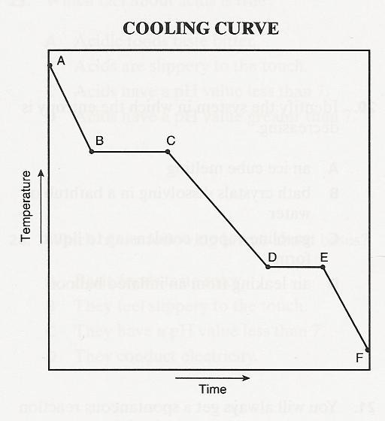

- Why doesn’t the temperature change during the time interval represented by line segment D-E?

16. How much heat is evolved when 1255 g of water condenses to a liquid at 100ºC?

17.Calculate how much energy must be removed to freeze completely 1500 g of water.

18. Calculate how much heat must be released to condense 100.0 g of steam to liquid water and lower the temperature of that water to 25°C.

- Draw energy diagrams for an endothermic and also an exothermic reaction. Label the change in enthalpy on each diagram. State whether there is net heat energy absorbed or released for each diagram.

