AP Chemistry Unit 8 Equilibrium Problem Sets.
Problem Set 1 – Equilibrium Concepts and Keq
1 | 2
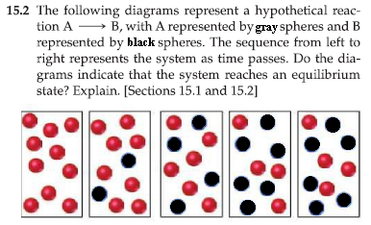 | 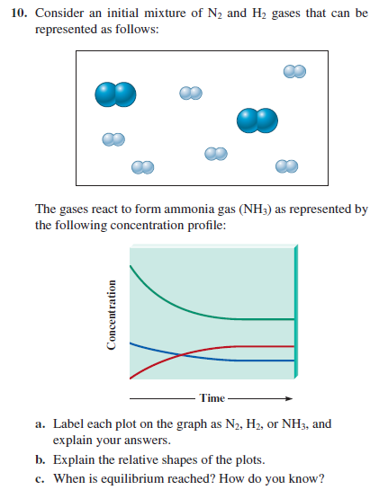
3 | 4
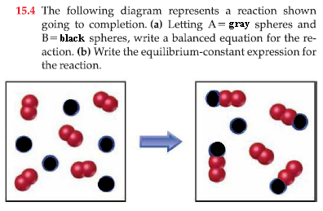 | 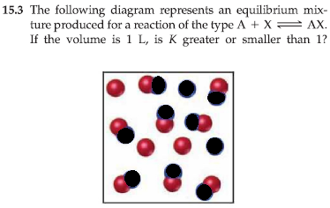
5 | 6
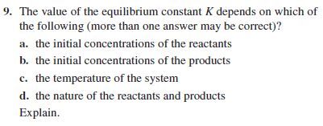 | 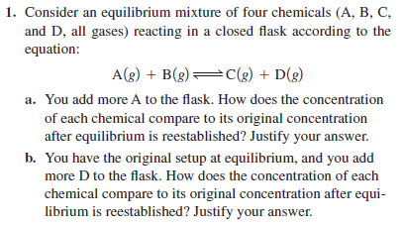
7 | 8
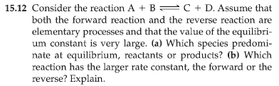 | 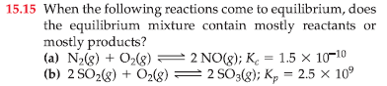
9 | 10
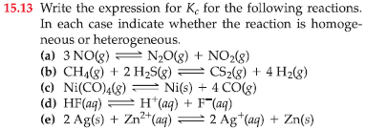 | 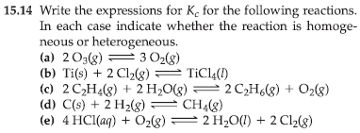
11 | 12
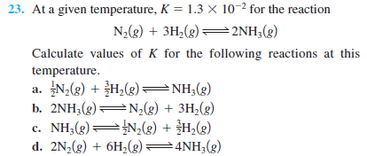 | 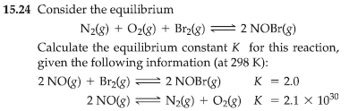

Problem Set 2 – Equilibrium Constant Calculations

1 | 2
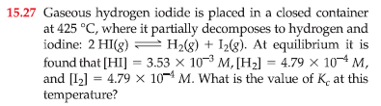 | 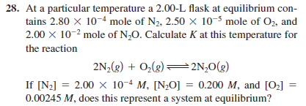
3 | 4
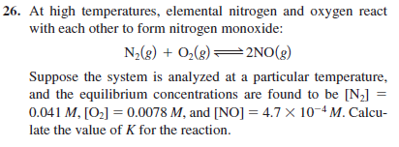 | 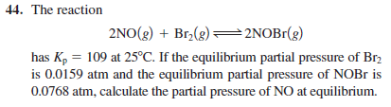
5 | 6
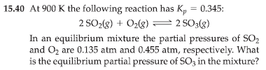 | 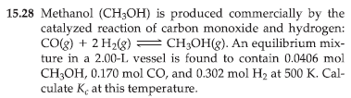
7 | 8
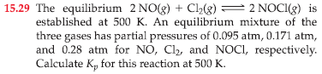 | 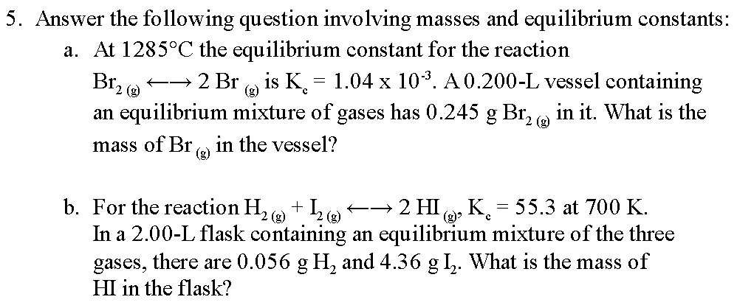
9 | 10
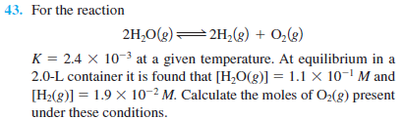

Problem Set 3 – Applications of K: Direction (Q) and Extent of Reaction (ICE)

1 | 2
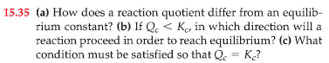 | 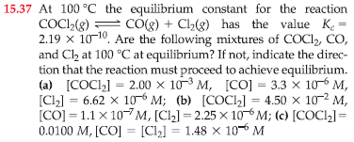
3 | 4
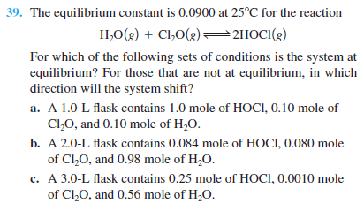 | 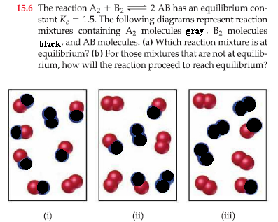
5 | 6
At a particular temperature, a 2.00-L flask at equilibrium contains 2.80 x 10⁻⁴ moles of N₂, 2.50 x 10⁻⁵ moles of O₂, and 2.00 x 10⁻² moles of N₂O based on:  N_{2 (g)} + O_{2 (g)} ←→ 2 NO _{(g)}. In a different trial of the same reaction, [N₂] = 2.00 x 10⁻⁴ M, [N₂O] = 0.200 M, and [O₂ ] = 0.00245 M, does this represent a system at equilibrium? If not, what directional shift must take place to establish equilibrium? | 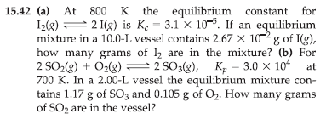
7 | 8
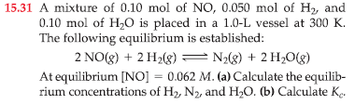 | 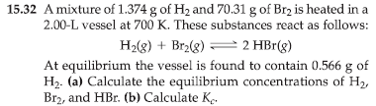
9 | 10
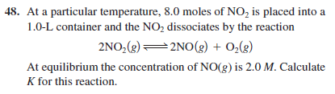 | 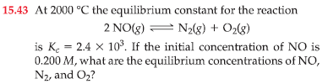
11 | 12
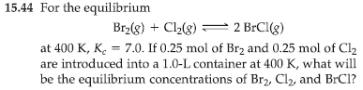 | 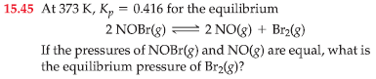
13 | 14
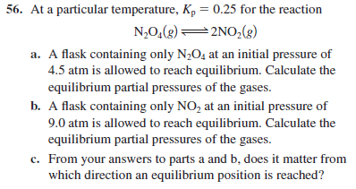 | 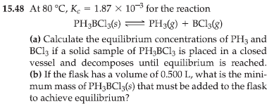
15 | 16
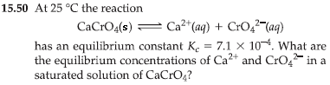

Problem Set 4 More ICE and Le Chatelier’s Principle

1 | 2
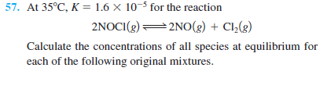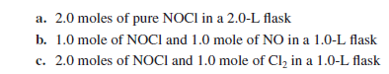 | 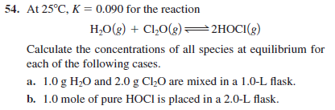
3 | 4
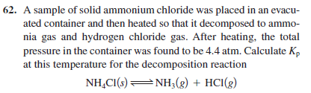 | 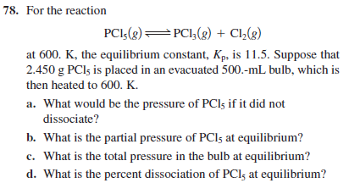
5 | 6
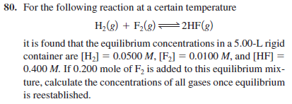 | 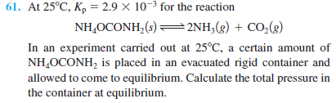
7 | 8
Phosgene, COCl₂, is prepared from CO and Cl₂ according to the following equation: CO + Cl₂---> COCl₂.  Kc at 395 °C is 1.23 x 10³. If 2.00 mol of CO and 3.50 mol of Cl₂ are added to a 5.00 liter reaction vessel at 395 °C, what would the equilibrium concentrations be for all species? | 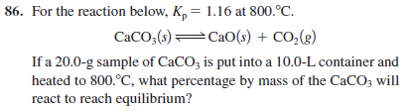
9 | 10
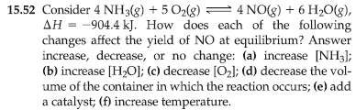 | 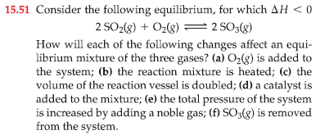
11 | 12
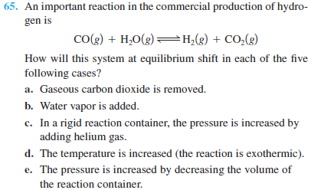 | 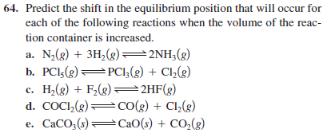
13 | 14
Methanol (CH₃OH) can be made by the reaction of CO with H₂: CO _{(g)} + 2 H_{2 (g)} ⬄ CH₃OH _{(g)}  a)Use the following thermochemical data to calculate ∆H° for this reaction:  CO _{(g)} -110.5 kJ/mol  CH₃OH _{(g)} -201.0 kJ/mol  b)To maximize the equilibrium yield of methanol, would you use a high or low temperature? Explain.  c)To maximize the equilibrium yield of methanol, would you use a high or low pressure? Explain. | 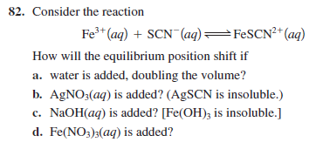
15 | 16
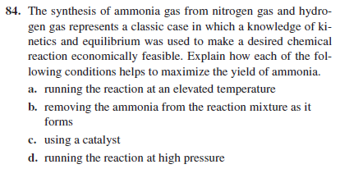 | 