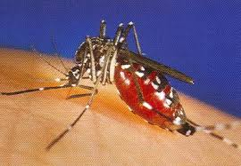
The West Nile Virus is a non communicable disease that affects the central nervous system. The main causes to the West Nile Virus are mosquitoes. Birds are the most highly infected species of the West Nile Virus. West Nile virus is through the bite of an infected mosquito. Mosquitoes become infected when they feed on infected birds, which may circulate the virus in their blood for a few days. The virus eventually gets into the mosquito's salivary glands. When mosquitoes bite the virus may be injected into humans and animals, where it can multiply and possibly cause illness.
Most people infected with the West Nile Virus have little or no symptoms. Mild symptoms would be fever, headache, body ache, fatigue, and eye pain. For serious symptoms would be high fever, severe headache, stiff neck, confusion, coma, pain, and lack of coordination. Currently there is no treatment/vaccine for the West Nile Virus. The only cost that a person may have to spend is time, because there is nothing to purchase unless you purchase some kind of mosquito control. The best way to try and prevent yourself from getting the West Nile Virus is to invest in mosquito control. Eliminate standing pools of water where mosquitoes breed, such as in old tires, buckets, un used swimming pools.
Facts, West Nile virus originated in Uganda in eastern Africa and first arrived in the United States in the summer of 1999. The first case was reported in New York and has since spread throughout the U.S. The virus is spread when a mosquito bites an infected bird and then bites a human. Most people who are bitten by a transmitting mosquito will never notice any symptoms at all.
Works Cited
www.statisticbrain.com/
www.cdc.gov
www.health.howstuffworks.com/

