Writing good answers to AP kinetics questions

Most of these tips are based upon free response questions from the old curriculum, simply because as yet we having nothing else to go on, but having said that, all of these ideas are likely to still remain relevant going forward.
1. When deriving a rate law from initial rate data in a FRQ, in nearly all cases it will be necessary to justify your answer by showing some kind of work. Essentially there are three ways to do this;
Firstly one could write a paragraph of prose, outlining which experiments are being compared, which reactant concentrations change and which are kept constant, followed by an explanation of how that affects the rate, and therefore derive the order with respect to the reactant that changed. That can get VERY messy, very quickly, especially when a set of data has one of those annoying combinations that fail to give you a pair of experiments that keep one of the reactants constant while changing another. As a result I generally don’t advise the ‘prose method’.
Secondly, one can set up what I call a ‘table of comparisons’. For example, from the initial rate data shown below;
Expt. | [A] | [B] | Relative Rate
1 | 1.0 | 1.0 | 1
2 | 1.0 | 2.0 | 2
3 | 2.0 | 1.0 | 4

I would construct this ‘table of comparisons';
Compare Expt.’s | [A] | [B] | Relative Rates | Orders
1 and 2 | x1 | x2 | x2 | 1st order wrt [B]
1 and 3 | x2 | x1 | x4 | 2nd order wrt [A]

Thirdly, use the ‘math method’. The math method is preferred by me when there is unhelpful data (as described above) that fails to keep a particular reactant constant while investigating another. Take for example, the data table of initial rates that appears in FRQ 1997, 4, where an investigation of the [B] on the rate is always clouded by the simultaneous change of [A].
Experiment | Initial  [A] | Initial  [B] | Initial Rate  of Formation  of C (mol L⁻¹ min⁻¹)
1 | 0.25 | 0.75 | 4.3 x 10⁻⁴
2 | 0.75 | 0.75 | 1.3 x 10⁻³
3 | 1.50 | 1.50 | 5.3 x 10⁻³
4 | 1.75 | ?? | 8.0 x 10⁻³
Here, the order with respect to [A] is established easily (and the ‘math method’ is not really necessary), but carrying the order with respect to [A] forward to the second ‘math method’, makes finding the order with respect to [B] relatively easy (which would not be the case without the use of the ‘math method’).
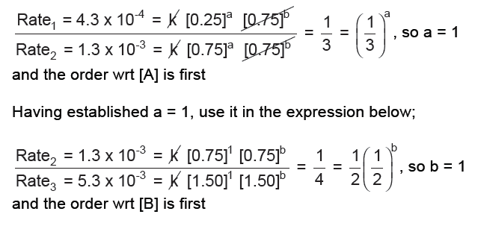
2. The units for rate constants are almost always subject to a scoring point so ensure that you understand how to get this right!
3. In most cases on the AP exam in the past, if an intermediate appears in the slow step of the reaction, it is replaced by the reactant that it depends upon in a fast equilibrium step. Look out for intermediates that lead to fractional rates as in 2009.
4. The (full) justification of a mechanism usually requires three, separate considerations;
i. Do the reactants of the slow step match the species that are in the rate law?
ii. Does the stoichiometry of the slow step match the orders in the rate law?
iii. Do the individual steps of the mechanism add up to the overall stoichiometry of the equation?
Not all questions necessarily require all of these, but you had better be prepared to give each one in various situations.
5. Be aware that ‘rates’ are sometimes expressed as shown below. It’s nothing new, but don’t let either the signs, or the use of Delta confuse you. Generally it has not been necessary to to use negative signs to show a reactant concentration declining, but just be aware of the simple relationship between signs and concentrations either increasing or decreasing.

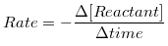
OR
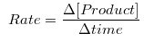

6. Another thing to be aware of is the idea that rate constants can be expressed in more than one way. Consider this reaction and data from 2008, 3.
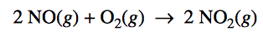
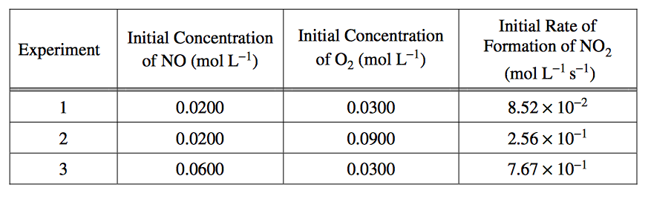Leading to this rate law:
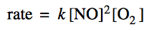And in turn to this expression for k:
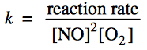OK, so far so good, here’s where one of two things can occur.
a. If we assume the rate of the reaction is the same as the rate of formation of NO₂, then simply substitute in values from experiment #1, according to;
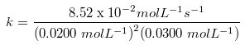
= 7.10 x 10³ L² mol⁻² s⁻¹
This is what I usually do, never bothering with b. below.
b. There is another situation that requires that the rate constant, k, be different to a reflect a coefficient of 1. In this case, because the stoichiometric number for the compound that is used to monitor the rate (NO₂) is 2, then we must half the rate, to reduce the coefficient to 1, and hence get a value of 3.55 x 10³L² mol⁻² s⁻¹ according to the calculation below.
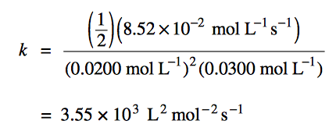
To my knowledge this has only ever come up once, in this particular free-response question from 2008, and even then, either answer for k was accepted. If one method over the other was required, I would imagine that the question would need to be more/very specific.
7. When justifying an order when ‘straight line’ graphical data is presented, there is some potentially conflicting information presented in the scoring standards by the College Board. For example, when comparing the official answers for 2005B, 3 and 2011, 6, in one case in was apparently OK to simply say, ‘It is ‘0/1/2′ order because the graph of ‘[X] / ln[X] / [X]⁻¹ versus time is a straight line’, and in the other case it appears that more was expected, i.e., that the answer required a more than just a reference to the fact a straight line was produced.
This is easy to do if the order in question is zero, since one can say that the changing concentration of X leads to no change in the slope of the graph, i.e., no change of rate so it must be zero order, but to justify it for first or second order plots, where ln[X] and [X]⁻¹ lead to straight lines, seems to me to require more math than is reasonable in the context of an AP chemistry exam.
In short, for zero order justifications in straight line graph situations, I would be inclined to always add a few words of explanation (as above), but for first and second order straight line graph situations, I would be inclined to simply limit my justification to saying that, ‘the plot of ln[X] or [X]⁻¹ yields a straight line‘. This may explain the differences in the two, College Board scoring standards.

